

**NILE UNIVERSITY**

**Toolbox of multiple commands**

**Aligner tool**

**By:**

Mennatullah Mahmoud 18101713

Menna Abdelsattar 18101590

Moaz Rizkallah 18102436

Submitted in partial fulfillment of the requirements

for Bioinformatics Project

February 2021

**Table of Contents**

**1. Introduction 3**

**2. Methodology 5**

2.1 Our data 5

2.2 The ToolBox 10

2.2.1 Pairwise Alignment 14

2.2.2 Multiple Sequence Alignment 18

2.2.3 Conserved Regions 23

2.2.4 Phylogenetic Tree 29

2.2.5 Counting kmers 33

2.2.6 Graph 35

2.3 Program analysis 42

**3. Results 45**

3.1 Pairwise Alignment 45

3.2 Multiple Sequence Alignment 50

3.3 Conserved Regions 56

3.3 Phylogenetic Tree 60

3.5 Counting kmers 65

3.6 Graph 65

**4. References 67**

**5. Contributions 68**

# 1. Introduction

Nowadays, Bioinformatics field has been aggregating all over the world. Bioinformatics is a sub discipline of biology and computer science concerned with the acquisition, storage, analysis, and dissemination of biological data, most often DNA and amino acid sequences. So, it is a field of computational science that has to do with the analysis of sequences of biological molecules. It usually refers to genes, DNA, RNA, or protein. Bioinformatics, as a new emerging discipline, combines mathematics, information science, and biology and helps answer biological questions. Most bioinformatics scientists use Linux operating system. As it is free, fast, secure and does not slow down after a while and does not limit your productivity. Besides, it does not need extra antivirus protection besides regular updates, has tens of thousands of programs available for free, has a vigorous community who are willing to help you solve any problems you might have. This makes it necessary to use Linux for genomics and many other useful operations. There are several

Linux Distributions, commonly called “distros” as Ubuntu Linux it is the most commonly used. Moreover, Linux has shell or terminal. A shell is a program that receives commands from the user and gives it to the OS to process, and it shows the output. Linux's shell is its main part. Its distros come in GUI (graphical user interface), but basically, Linux has a CLI (command line interface). The Linux command line is a text interface to your computer. Also known as shell, terminal, console, command prompts and many others, is a computer program intended to interpret commands. Command lines are easy to use and perform functions in a few numbers of lines not like any programming languages they perform operations in a large number of code lines. it has auto complete option. From the command line, you can navigate through files and folders on your computer. Using a command line, you can perform almost all the same tasks that can be done with a GUI. However, many tasks can be performed quicker and can be easier to automate and do remotely.

In our project, our aim is to develop a distinguished toolbox that can satisfy multipurpose for the Bioinformatics field. We named our tool as “Aligner” and this is the name of our bash script as well. We used a simple graphical user interface (GUI) which is a form of user interface that allows users to interact with electronic devices through graphical icons and audio indicator such as primary notation, instead of text-based user interfaces, typed command labels or text navigation. We used GUI for better visualization of the tool objects when displayed to user. Also, GUI allow the users not to deal with the terminal and open the bash script directly. Although Aligner opens as a GUI program, it is based on command-line for doing all the functions that our tool performs. Aligner can Perform pairwise alignment using blast on command line between a pair of fasta files of Protein or DNA in 2 organisms. It also performs multiple sequence alignment between all files and determine the possible conserved regions that may have a specific function in 2 organisms by pfam website which is showed inside the tool. Aligner takes an input folder containing multiple fasta files and generate one fasta file containing all these files then make the MSA process. Moreover, Aligner tool draws a phylogenetic tree which is a diagram that represents evolutionary relationships among organisms. Finally, it calculates how many Kmers found in any file, and determine the differences between pairs in two types of graphical view (terminal graph and bar plot graph).

# 2. Methodology

## 2.1 Our data

Before making our toolbox, we have to download the protein data we will work on. We downloaded 34 FASTA files, 17 fasta files of alpha globin genes of human, gorilla, mouse, cat, dog, chicken, pig, horse, frog, goat, sheep, bovine, macaca, rabbit, rat, zibrafish and chimpanzee and 17 fasta files of beta globin genes of the same organisms as well. The HBB gene provides instructions for making a protein called beta-globin. Beta-globin is a component (subunit) of a larger protein called hemoglobin, which is located inside red blood cells. These cells then travel through the bloodstream and deliver oxygen to tissues throughout the body. The HBA gene provides instructions for making a protein called alpha-globin. Alpha-globin is a component (subunit) of a larger protein called hemoglobin, which is the protein in red blood cells that carries oxygen to cells and tissues throughout the body. So, The HBB gene provides instructions for making a protein called beta-globin. Beta-globin is a component (subunit) of a larger protein called hemoglobin, which is located inside red blood cells. In adults, hemoglobin normally consists of four protein subunits: two subunits of beta-globin and two subunits of a protein called alpha-globin, which is produced from another gene called HBA. Each of these protein subunits is attached (bound) to an iron-containing molecule called heme; each heme contains an iron molecule in its center that can bind to one oxygen molecule. Hemoglobin within red blood cells binds to oxygen molecules in the lungs. These cells then travel through the bloodstream and deliver oxygen to tissues throughout the body. We used uniprot website to download our data. Uniprot is a genome browser and a freely accessible database of protein sequence and functional information, many entries being derived from genome sequencing projects. It contains a large amount of information about the biological function of proteins derived from the research literature. The mission of UniProt is to provide the scientific community with a comprehensive, high-quality and freely accessible resource of protein sequence and functional information. We searched for alpha and beta globin genes of these organisms, then we downloaded the fasta file of Protein sequence of each organism. As mentioned, the files are FASTA, and each one is of size ranged between 265 B to 285 B. And now, we have our data ready to begin making and testing our Aligner tool.

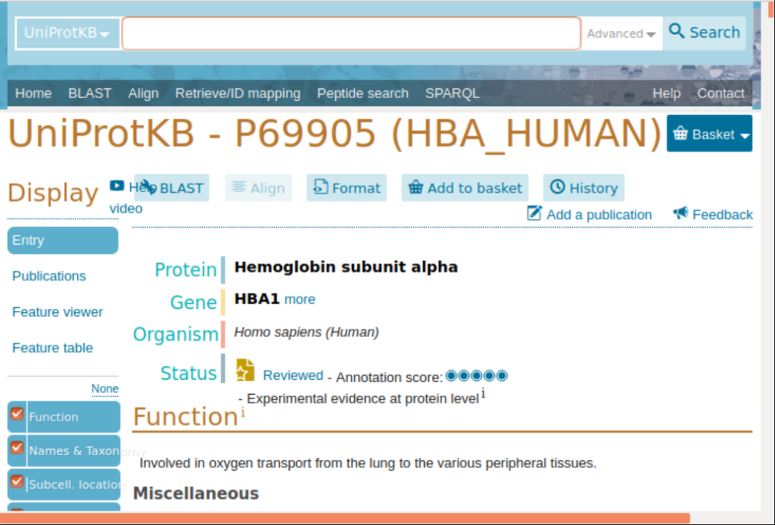

This is human alpha globin gene; we get the fasta file of it.

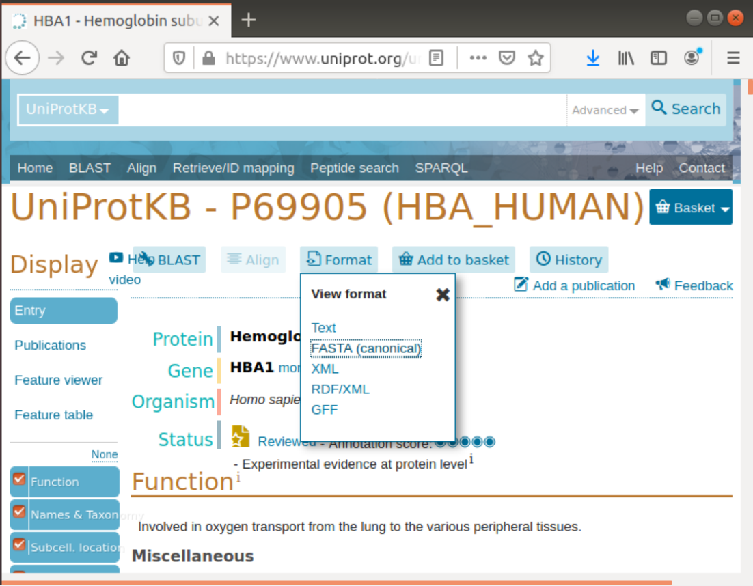

Then we downloaded this fasta format file and saved it as human_alpha_globin.fa.

Then we renamed the name that is written in the file itself after the greater than sign “>” so that name is shorter to appear in the tree clearer when testing the phylogenetic tree of these organisms.

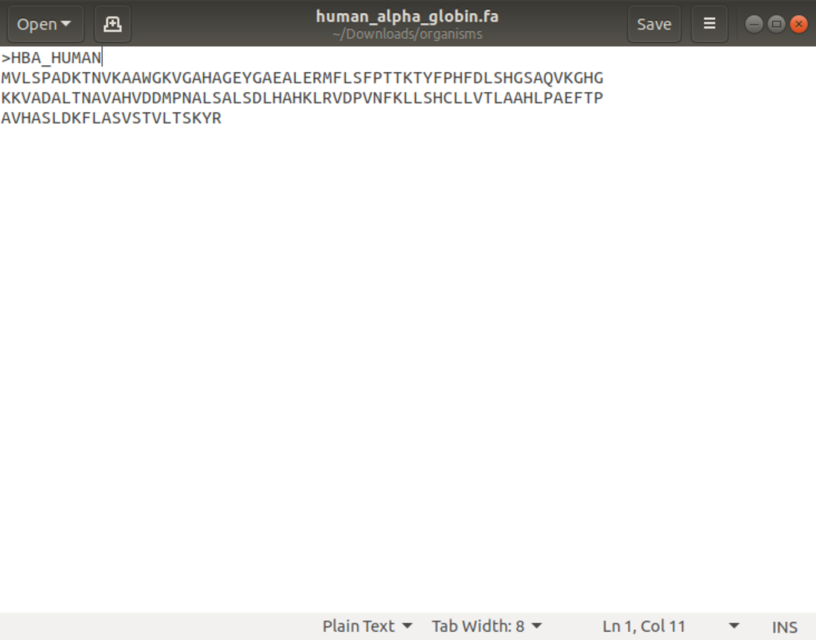

We did the same process for downloading alpha and beta globin genes of the 17 organisms as well. Now we have 34 fasta files 17 for alpha globin and 17 for beta globin genes. We put all the 34 files in one folder named it organisms.

The folder is done by mkdir command:

$ mkdir organisms

Then we copied the files into it by the command:

$ cp *.fa organisms

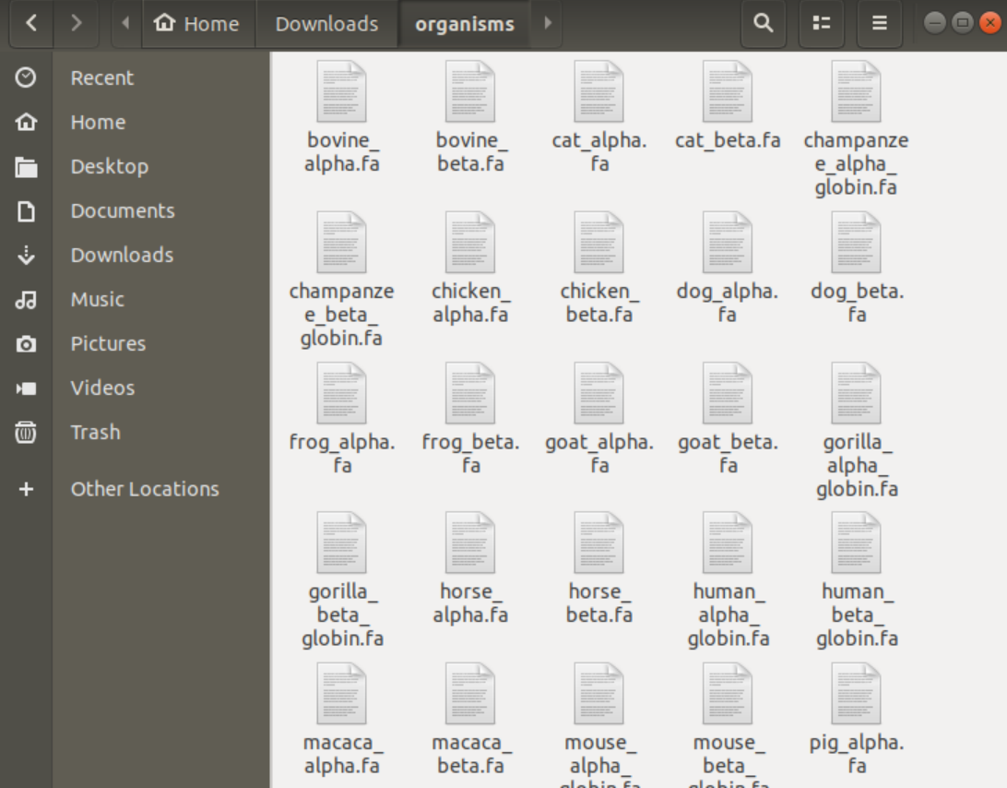

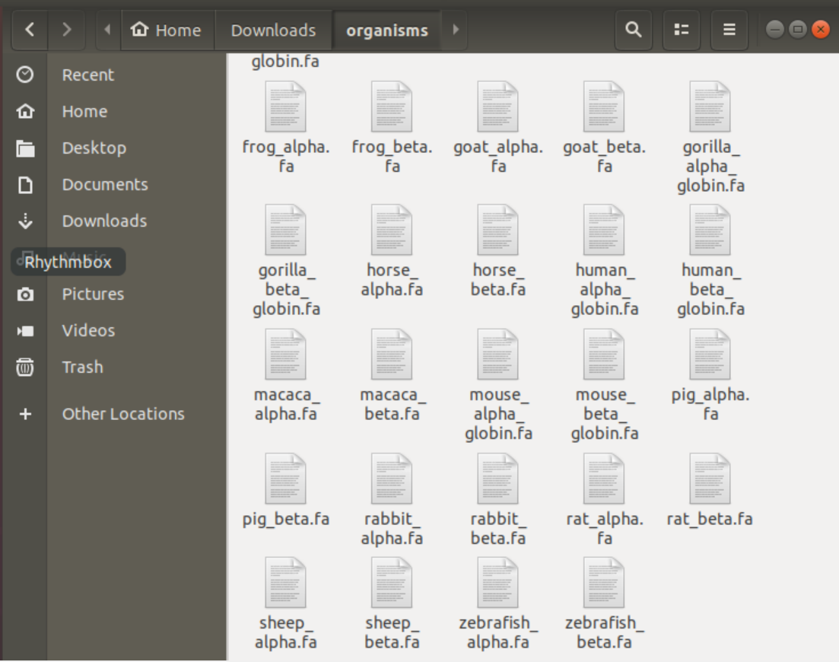

Now we have the folder organisms containing all the organism’s alpha and beta globin genes as shown in the figure.

## 2.2 The ToolBox

Aligner consists of various command lines to perform specific functions by using terminal in linux. Aligner has 6 options; the user has to choose from number 1 to 6. Firstly, [1] Aligner tool makes a pairwise alignment using blast. Then [2] the second option is Multiple sequence alignment; Aligner takes an input folder containing any number of fasta files and generate one fasta file containing all these files then make the MSA process. The multiple sequence alignment is done by muscle and kalign tools, the user has to choose what tool to perform MSA process. Also, muscle has 2 options of output formats clastalw and html. Besides kalign has 2 output formats clastal and MSF. [3] It determines the possible conserved regions that may have a specific function in the two organisms as well as. The tool asks the user to enter the type of file, user has to choose between clw, html, clu and msf formats. Then, user can use pfam to show the function of these conserved regions. [4] Aligner draws a phylogenetic tree. The tool asks the user to choose the MSA fasta file that is generated by the tool in the MSA step. The tree is generated automatically in two formats newick format and visualization as a tree graph. Besides, [5] Aligner calculate how many kmers in any file the users enter. The tool asks the user to input the file and what letter(s) to be counted. [6] Aligner shows the difference between the counts in graphical view. The main graph of Aligner is bar plot graph which output the graph into external jpg photo placed in the same directory the user open.

For applying GUI, we installed zenity by command lines:

$ sudo apt-get update -y

$ sudo apt-get install -y zenity

We made a bash script by using this command:

$ nano Aligner.sh

The bash script will be opened, and all the commands will be written in it so as to be run once with one command. After we have done writing all the commands, we will press ctrl x to exit and press y to save the information written.

We have to run the bash script which contains all of that previously written commands to get the results by this command:

$ bash Aligner.sh

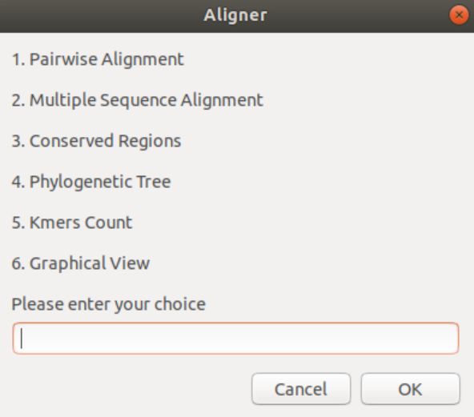

There is another way to run Aligner tool from the file itself in the directory the user is opening where user don’t have to go to terminal at all. The tool runs once the user press on the file Aligner.sh.

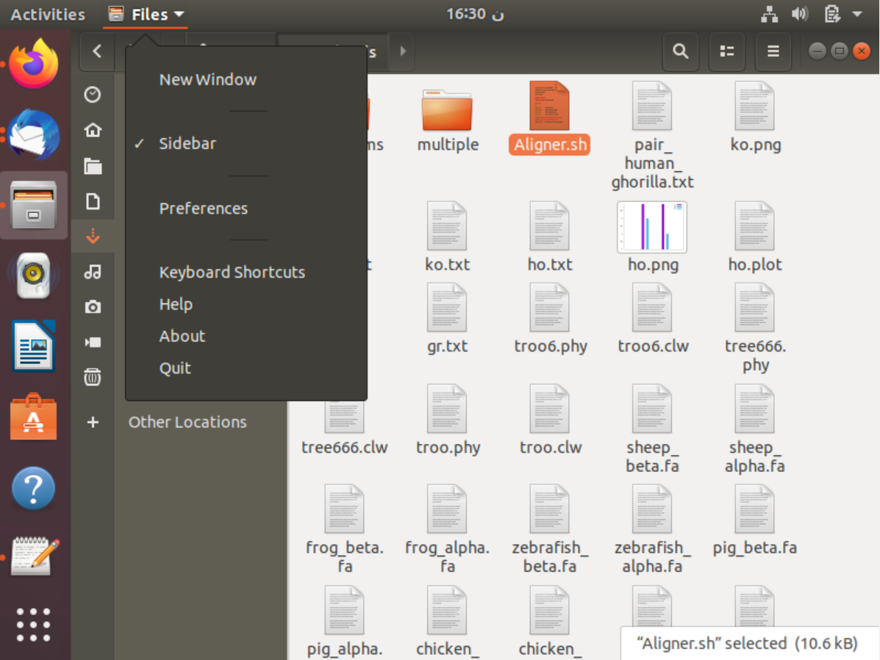

User has to click on files and select preferences.

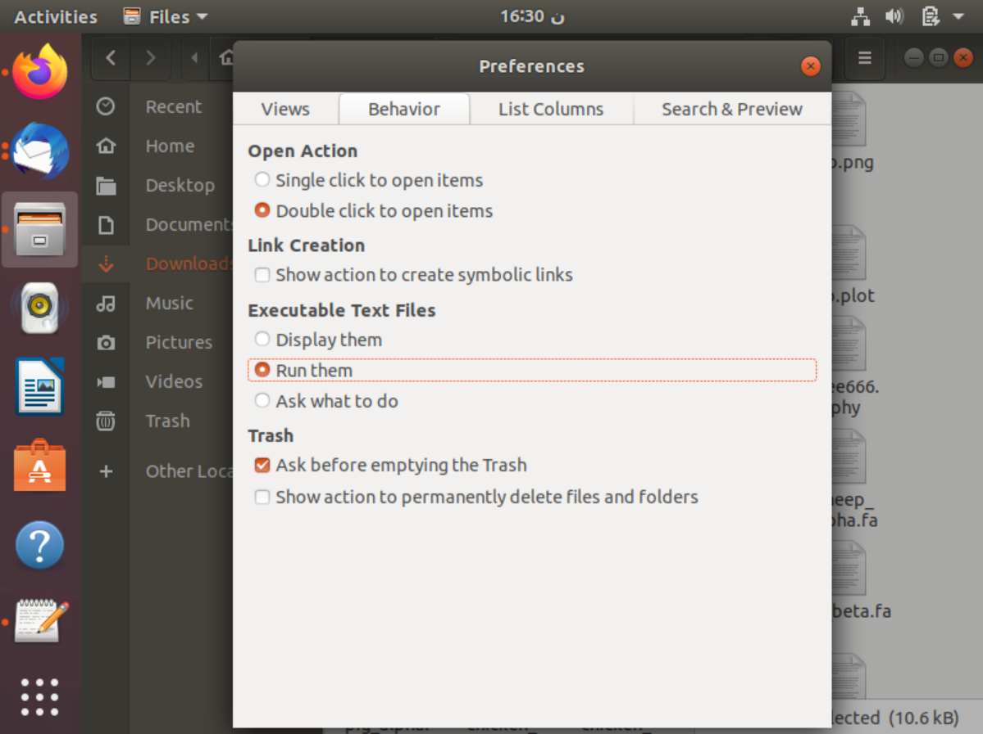

After that user has to press on behavior and select Run them. So that the Aligner tool would run automatically once the user clicks on the file of bash script which is Aligner.sh.

### 2.2.1 Pairwise Alignment

We made the alignment on protein sequences between human alpha globin gene and gorilla alpha globin gene. But, Aligner tool can function on both DNA and protein, “BLASTn” tool for DNA and “BLASTp” tool for protein sequence.

Pairwise Sequence Alignment is used to identify regions of similarity that may indicate functional, structural and/or evolutionary relationships between two biological sequences (protein or nucleic acid). Besides, BLAST is a Basic Local Alignment Search Tool. It finds regions of similarity between biological sequences. The program compares nucleotide or protein sequences to sequence databases and calculates the statistical significance. While BLASTn which we specifically used refers to Nucleotide Blast which is used to search a nucleotide query against nucleotide subject sequences or a nucleotide database. Also, BLASTp used for protein blast which is used to search a protein query against protein subject sequences or protein (amino acid) database.

After opening Aligner, user should select choice number 1 to make pairwise alignment. The tool asks the user to input the database. Here our database (subject) is human_alpha_globin gene so user selects this file. If user clicks on cancel, the process will be cancelled, and the tool will be closed.

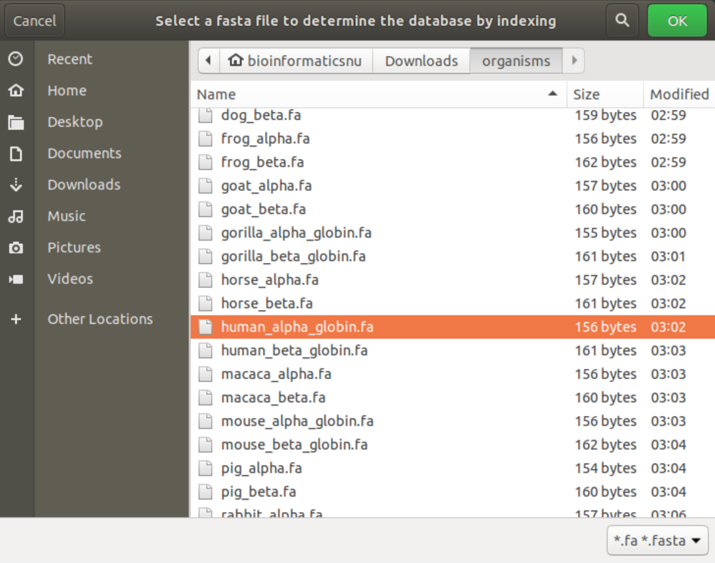

Indexing in the tool is made by this command:

$ makeblastdb -in $database_file -dbtype $type

Indexing exact pattern matching as it divides the database into parts, so when blast input the query to each part of the database, it is easier to find the identity between this query and the parts or the indexing files of the database than finding the identity between the query and all the database as the database is too large. When blast find the identities, it begins to make the pair wise alignment. So, indexing a genome can be explained similar to indexing a book. If you want to know on which page a certain word appears or a chapter begins, it is much more efficient/faster to look it up in a pre-built index than going through every page of the book until you found it. Same goes for alignments. Indices allow the aligner to narrow down the potential origin of a query sequence within the genome, saving both time and memory. indexing speeds up the mapping algorithms. Like the index at the end of a book, an index of a large DNA sequence allows one to rapidly find shorter sequences embedded within it. Thus, indexing is very efficient as it saves time and have better quality and performance than other ways.

After that the tool asks user to input the query, here our query is gorilla_alpha_globin gene so user select this file. Then press on ok.

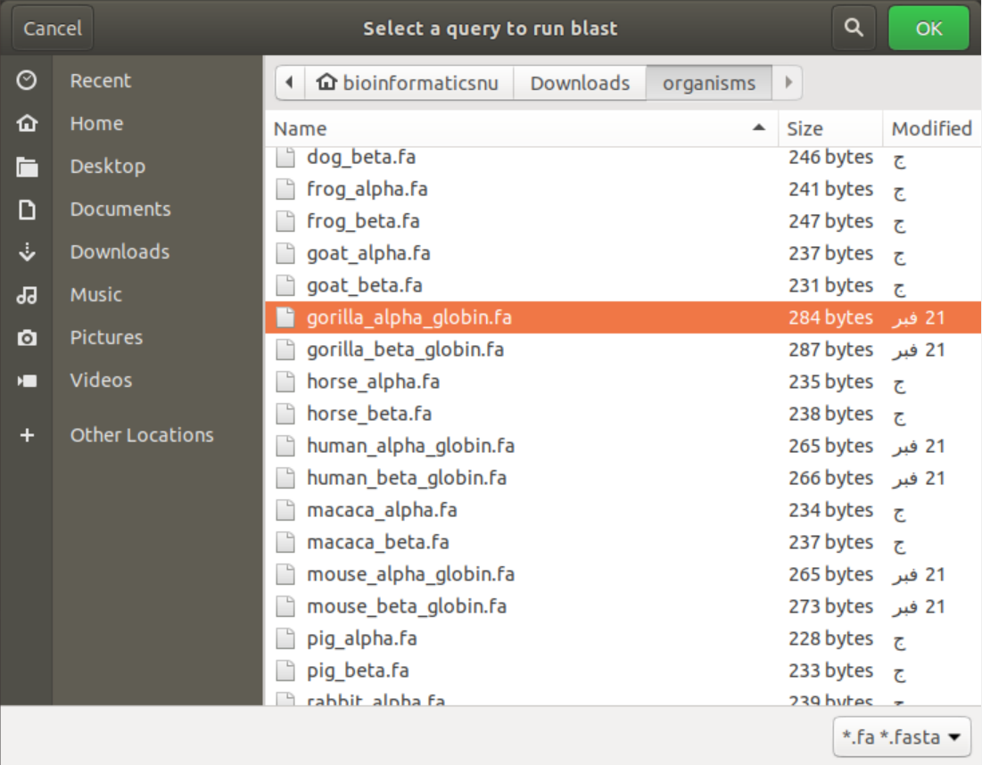

Aligner asks the user to select the data type of database and query DNA or protein. User selects protein and press ok.

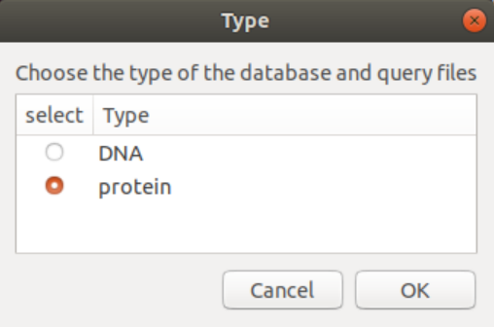

Aligner then asks user to write the name of the output file that will be generated from the pairwise alignment process by the tool. User enters the name and press ok.

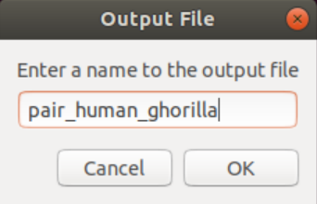

The pairwise itself is done by this command:

$ blastp -query $query_file -db $database_file -out $output.txt

Here we have completed the pairwise alignment between each pair. The results will be shown later in the results section.

### 2.2.2 Multiple Sequence Alignment

Multiple Sequence Alignment (MSA) is generally the alignment of three or more biological sequences (protein or nucleic acid) of similar length. From the output, homology can be inferred and the evolutionary relationships between the sequences studied. We tested our tool by a folder containing 34 fasta files of protein sequences, 17 of alpha globin and the others for beta globin genes of the 17 organisms mentioned before. We intended to make MSA on this large number of organisms improve our tool high efficiency and performance.

In Aligner, we tested the second-choice number two which is the multiple sequence alignment. Aligner asks the user to select the folder that has the fasta files that the tool will perform MSA process on them. Aligner filters the selection to folders only as no files can be selected. User chooses the folder organisms and press ok.

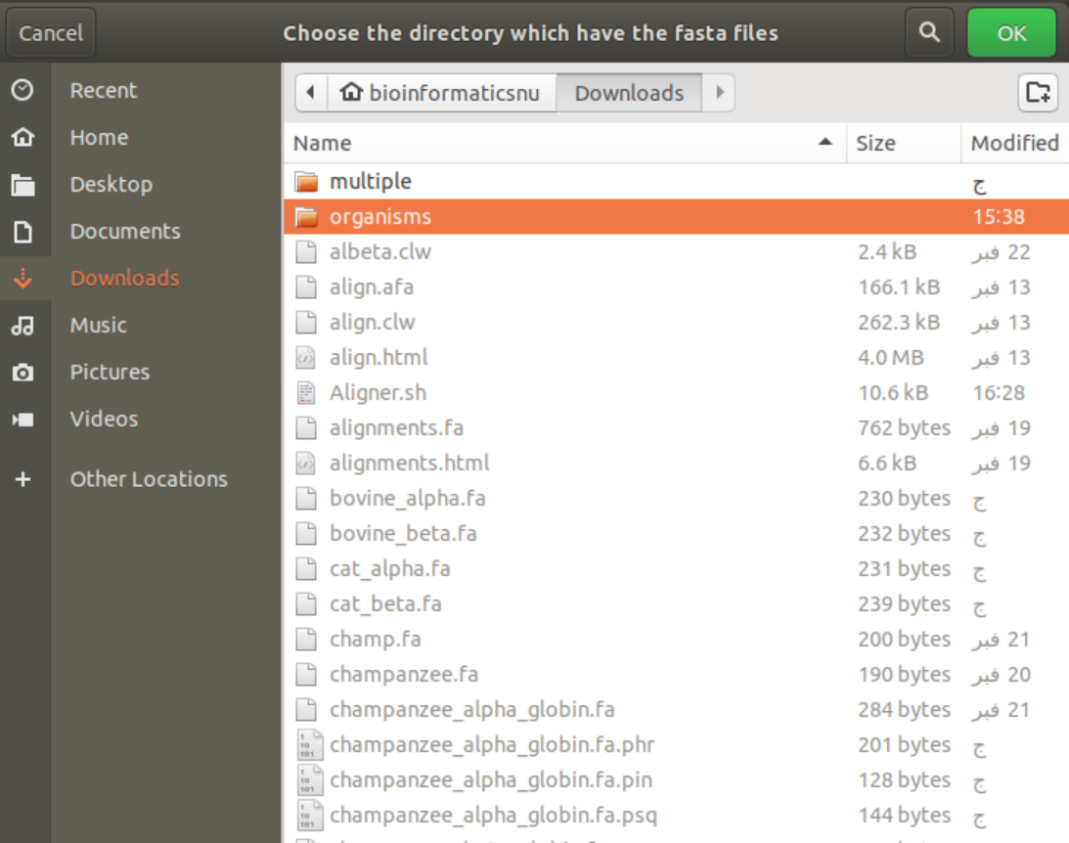

Aligner displays this information message to user.

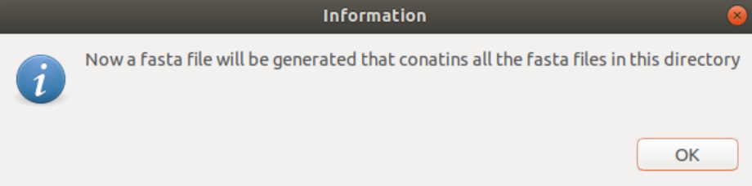

Here, Aligner takes all the files in the folder and copy then to one file using these commands:

$ for file in $directory/*.fa

$ do

$ cat $file >> $MSA_file.fa

$ done

Then Aligner asks the user to write a name to the output fasta file that is containing all the fasta files placed in the folder entered by user.

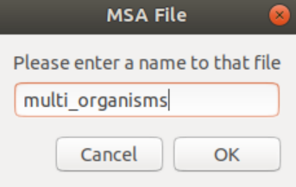

The tool asks the user to select the method of generating the multiple sequence alignment. We have chosen muscle.

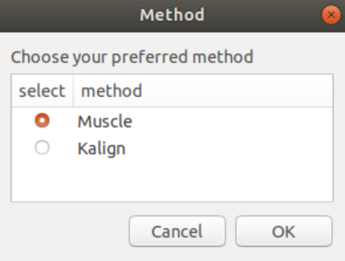

This command is used to make the pairwise alignment using muscle tool

$ muscle -in $MSA_file.fa -out $MSA_file.afa

Then, aligner asks the user to choose an output format of muscle to view the file of MSA with. User chooses clustalw and press ok.

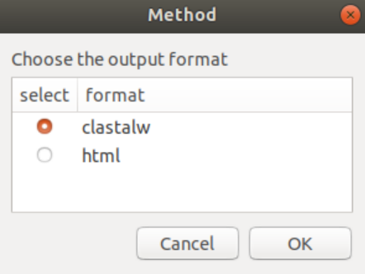

To use muscle in a clw format the tool uses this command:

$ muscle -in $MSA_file.fa -out $MSA_file.clw -clw

And for html it uses this one:

$ muscle -in $MSA_file.fa -out $MSA_file.html -html

If the user has chosen kalign tool, other formats will be available as MSF and clastal. We did all the previous steps again but instead of choosing muscle we have chosen kalign tool. The command of kalign was:

$ kalign -i $MSA_file.fa -o $MSA_file.afa

Besides, the clastal format and MSF format by these ones:

$ kalign -i $MSA_file.fa -f clu -o $MSA_file.clu

$ kalign -i $MSA_file.fa -f msf -o $MSA_file.msf

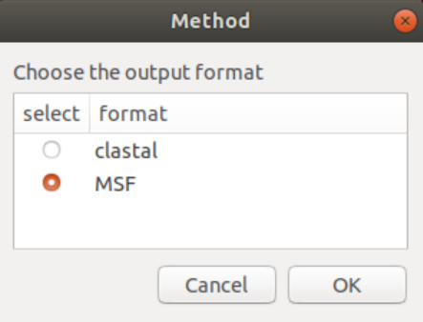

The results of the MSA will be discussed later in the result section.

### 2.2.3 Conserved Regions

We have to determine the conserved regions that have function in the two organisms. In evolutionary biology and genetics, conserved sequences refer to identical or similar sequences of DNA or RNA or amino acids (proteins) that occur in different or same species over generations. These sequences show very minimal changes in their composition or sometimes no changes at all over generations. So, a conserved sequence is a base sequence in a DNA molecule (or an amino acid sequence in a protein) that has remained essentially unchanged, and so has been conserved, throughout evolution. Conserved sequences can be categorized into two major categories, orthologous and paralogous. A conserved sequence is called orthologous when identical sequences are found across species and it is called paralogous when identical sequences are found within the same genome over generations. Human, Gorilla, Mouse and chimpanzee are orthologue as they are different species but have common genes and similar conserved regions. Conserved sequences help us find homology (similarity) among different organisms and species. Conserved sequence can also be used to mark the origination of genetic disorders and mutations. By comparing genomes which have a certain conserved sequence common to them we can easily identify anomalies, any exist. They mainly indicate functions between organisms. To know what the functions are indicated by the conserved regions, Aligner tool upload the sequence on pfam website to show their function. The Pfam database is a large collection of protein families, each represented by multiple sequence alignments and hidden Markov models (HMMs)

Proteins are generally composed of one or more functional regions, commonly termed domains. Different combinations of domains give rise to the diverse range of proteins found in nature. The identification of domains that occur within proteins can therefore provide insights into their function. Pfam also generates higher-level groupings of related entries, known as clans. A clan is a collection of Pfam entries which are related by similarity of sequence, structure or profile-HMM. The data presented for each entry is based on the UniProt Reference Proteomes but information on individual UniProtKB sequences can still be found by entering the protein accession. Pfam full alignments are available from searching a variety of databases, either to provide different accessions (e.g. all UniProt and NCBI GI) or different levels of redundancy. In our Aligner tool, the third option of choices is the conserved regions. Once user choose number 3, the tool asks the user to input a clustalw file to visualize it to user. Also the tool displays a message to the user showing in it information about what are the conserved regions and how to determine it.

The third option in Aligner is the conserved regions, first we made MSA between 4 organisms’ alpha and beta globin genes which are human, gorilla, mouse and chimpanzee. We did this in order to obtain a large, conserved region so we didn’t choose the same Protein sequence and the same clw file generated from MSA process on folder organisms that consists of 17 organism’s alpha and beta globin genes because the clw generated from their MSA doesn’t contain large conserved regions so that they don’t have function to be showed on pfam website. We did all the MSA steps again and chose the output four_org.clw file to obtain the functions of these regions on pfam. Firstly, we have written number 3 in the menu, then the tool asked for the type of file we want to show its conserved region, here we have chosen clw format

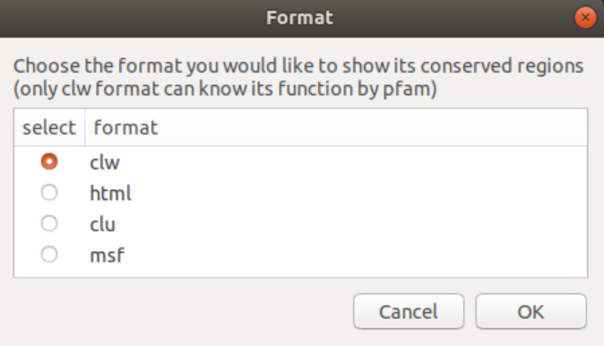

And then chose the clw file which is four_org.clw

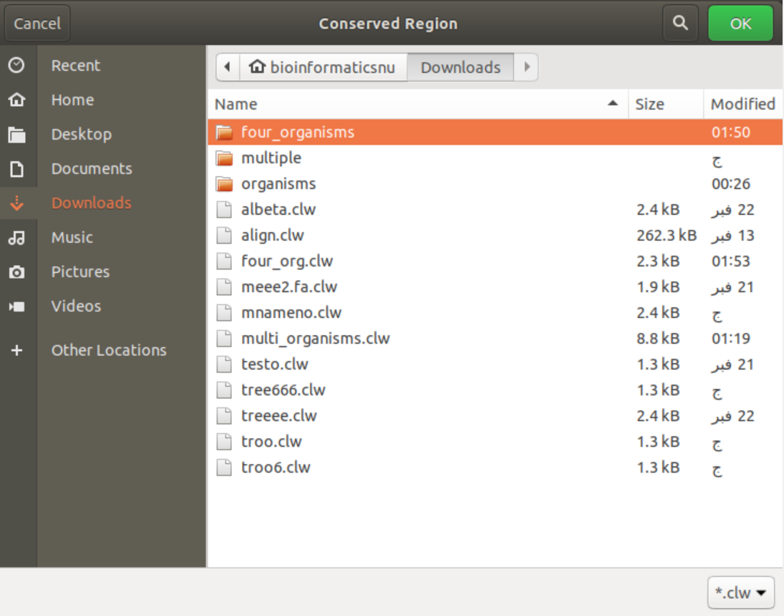

Here Aligner opens the file to the user and an information box to explain each symbol in the file.

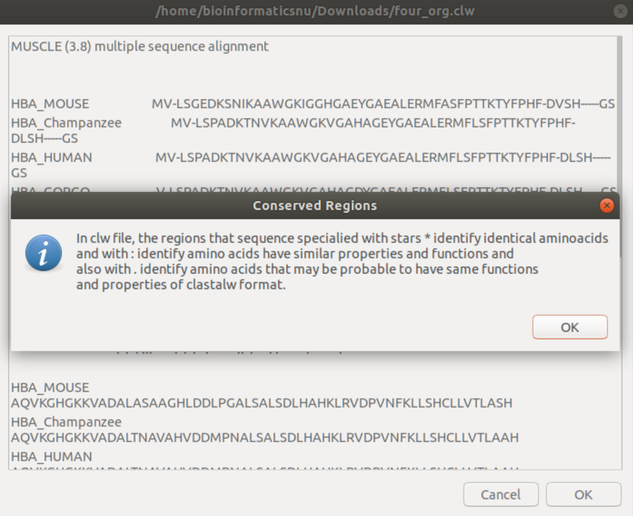

Aligner displays a question message to user asking users if they want to know the functions of conserved regions on pfam and asks if it is previously downloaded or not in order not to overwrite the pfam files. If user press no, Aligner will not download the pfam again to user and move to the next step. If user press yes, Aligner will automatically download the pfam to user. This will appear only if the previously entered format was clw because pfam doesn’t work on other file formats.

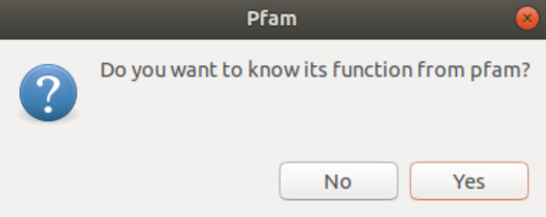



After downloading pfam, now it can be used locally on the computer without using their website using this command:

$ hmmsearch --tblout $output.txt -E 1e-5 --cpu 2 Pfam-A.hmm $cfile

Then, aligner asks the user to enter a name to the file that will consists of pfam information

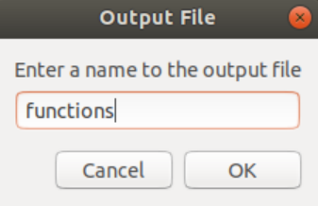

Here, we tested the html format as well but instead of choosing clw format on the first step we will choose html and select out html file to be previewed with the information box.

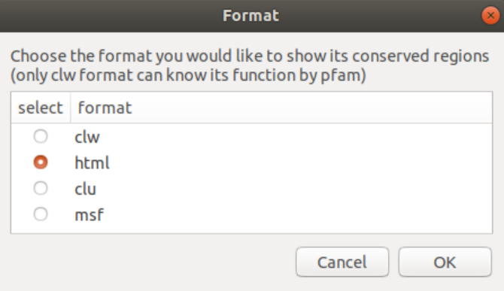

User select html and press ok.

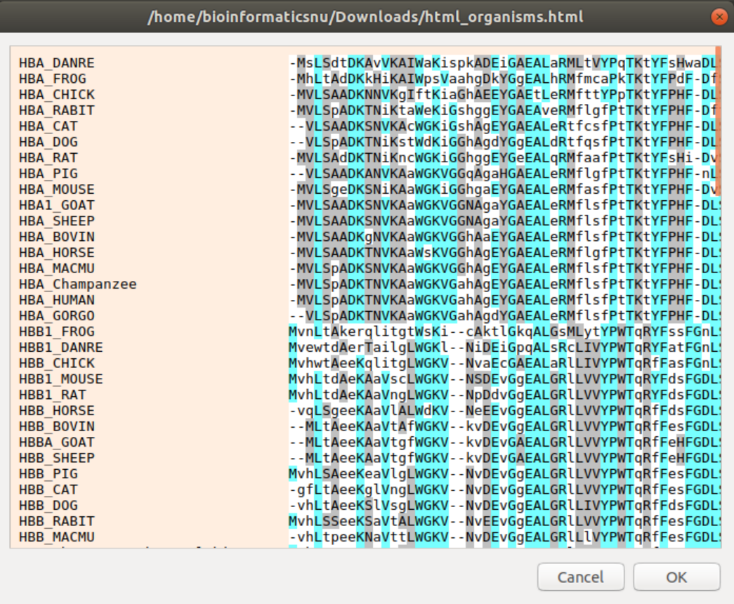

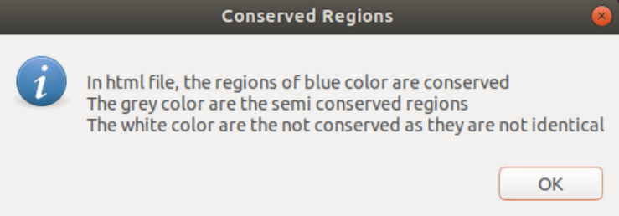

The detailed results will be discussed later in the result section as well.

### 2.2.4 Phylogenetic Tree

phylogenetic tree is a diagram that represents evolutionary relationships among different species, organisms, or genes from a common ancestor. It is useful for organizing knowledge of biological diversity, for structuring classifications, and for providing insight into events that occurred during evolution. Furthermore, because these trees show descent from a common ancestor, and because much of the strongest evidence for evolution comes in the form of common ancestry, one must understand phylogenetic trees in order to fully appreciate the overwhelming evidence supporting the theory of evolution. In trees, two species are more related if they have a more recent common ancestor and less related if they have a less recent common ancestor. The ancestor is in the tree “trunk”; organisms that have arisen from it are placed at the ends of tree “branches.” The distance of one group from the other groups indicates the degree of relationship; closely related groups are located on branches close to one another. Phylogenetic trees, although speculative, provide a convenient method for studying phylogenetic relationships. In bioinformatics, phylogenetic trees are also represented in Newick format in the form of brackets not only graphs where the more related species are placed in the same bracket and the less related ones are placed inside the bracket and all are placed within the main bracket and it ends with semicolon. ((A,b)c); The Newick Standard for representing trees in computer-readable form makes use of the correspondence between trees and nested parentheses.

In Aligner, the phylogenetic tree is the fourth option of choices, the user enters number four to make it

We renamed the beginning of each sequence for better visualization in the tree to become as shown:

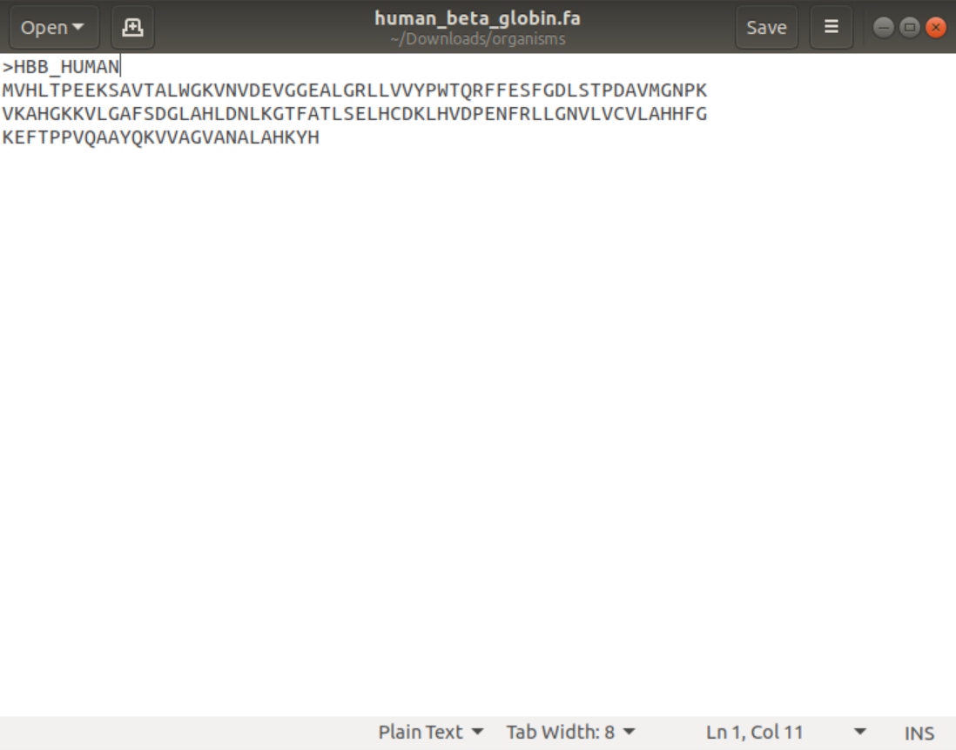

we tried the protein sequence of both folders of one of the four organisms and the other for all organisms. We tried two folders to produce two trees one is small and the other is large and to show the difference in visualization of newick format and graph visualization.

Firstly, Aligner asks the user to enter the name of fasta file which he wants to show it as a tree.

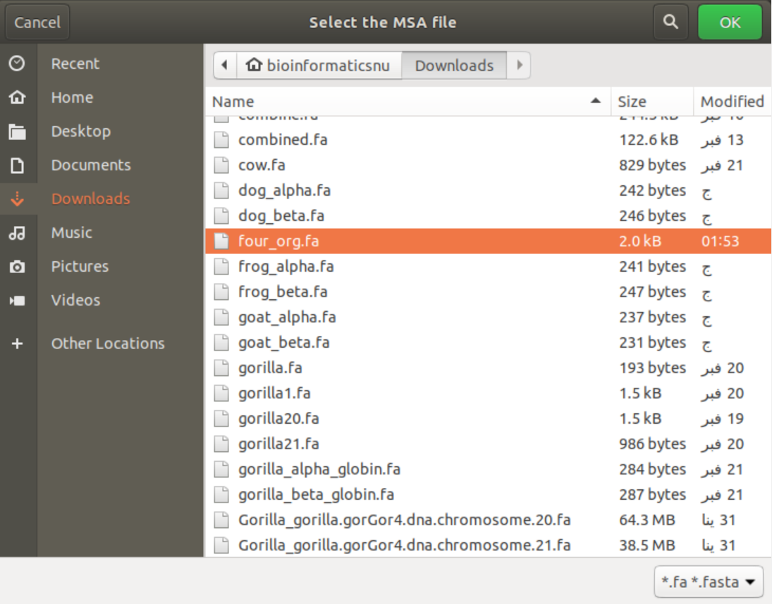

Here user selects the folder containing the 4 organisms as we said before. This is the small file so the tree would be small.

It also asks user to enter a name to the output tree file.

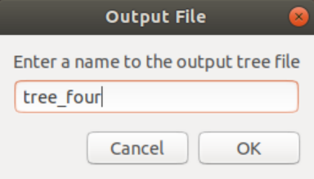

After that the tool will perform the phylogenetic tree and asks the user to select between the newick format and visualization of the tree as a graph.

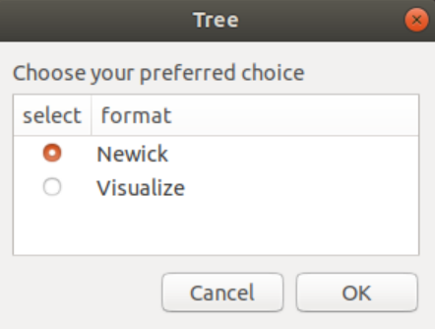

Aligner asks the user to select what format would the tree be represented. We will test it twice one for newick format and the other for visualize. It makes the tree using this command and then display the output file:

$ muscle -in $combinedfile -out $tree.clw -clw -tree1 $tree.phy

and for the visualization we used njplot by using this command:

$ njplot $tree.phy

The results of the trees files visualizations will be shown later in the results section.

### 2.2.5 Counting kmers

The kmer count is the fifth option of choices of Aligner tool. Once the user enters number five, the tool asks the user to enter the input file and user selects the file.

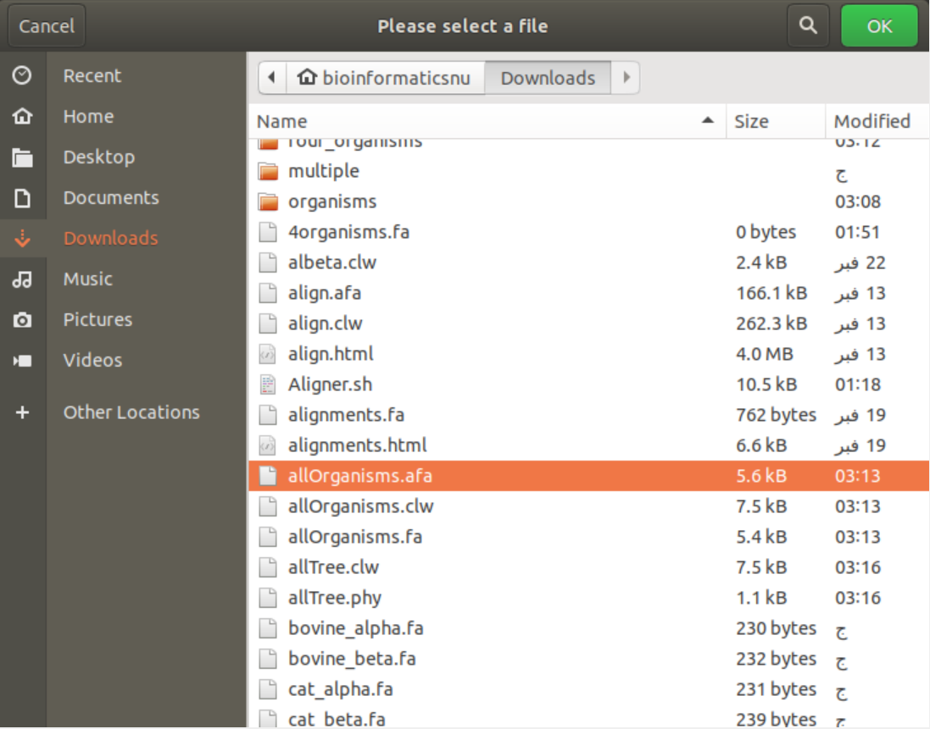

After that the tool asks the user to input the letter(s) to count. Here we tried kmer KA but the user can count any kmer with any length.

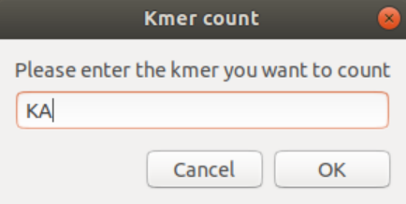

The count function is made by this command:

$ grep -c "$kmer" $file

then the tool counts the number of kmers entered by user. The result will be shown in the result section.

### 2.2.6 Graph

In our tool, the sixth choice is to visualize the different of counts of specific kmers between any number of files in 2 ways of graph the first is terminal graph and the second is barplot graph. The main graph of Aligner is bar plot graph which output the graph into external jpg photo placed in the same directory the user open.

Firstly, User writes number 6 to open the graph options. Aligner asks the user to select between these two types of graphs.

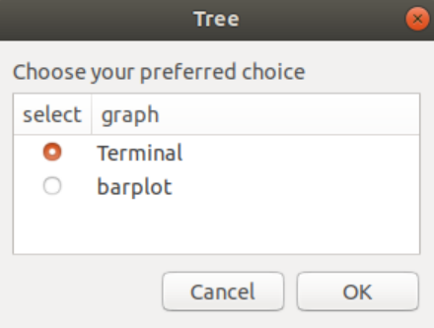

We will choose terminal at first, the tool then asks the user to enter the name of the output file.

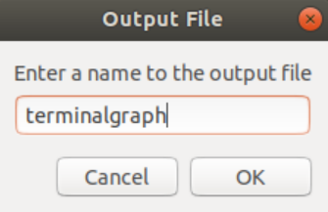

The bash script here makes an empty file to store all the data we will count to make the graph according to the all the saved numbers in this files.

$ touch $graph.txt

The tool has a slider to choose the number of counts and also number of files you want to involve in the graph. Aligner limits the counts of kmer to 50 kmer only because no graph can fit more than 50 bar.

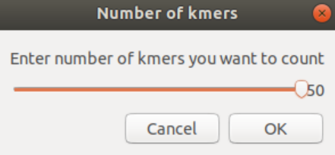

Here we adjusted the slider on 3 kmer to be counted

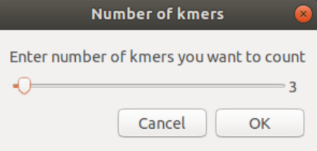

Here the bash script used for loop of this number of kmers entered to ask the user to enter the kmers itself by the same number. Inside the same for loop the name of the kmer will be stored in the file created to be clearly labeled in the output graph.

for (( i=1; i<=$nokmers; i++))

do

kmer=$(zenity --entry --title "kmer $i" --text "Enter the $nokmers kmer(s)")

x+=( $kmer )

printf "$kmer " >> $graph.txt

done

Then the tool asks the user to enter these kmers (if he has chosen to enter 50 kmer in the slider, 50 window will appear one after another asking the user to enter these kmers). Here Aligner opens 3 windows to write the kmers we want to count. We entered M, L and R kmers.

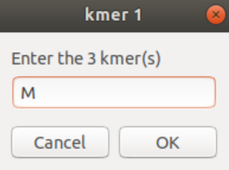

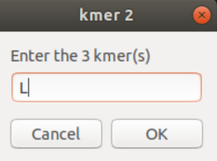

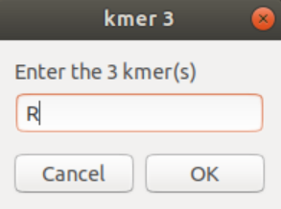

Aligner then asks to enter the number of files we want to involve in the graph. Here we have chosen 2 files but user can enter up to 50 files as well.

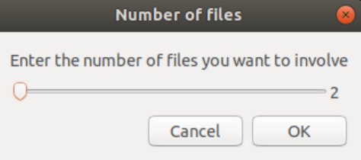

Then, Aligner asks the user to select the 2 files.

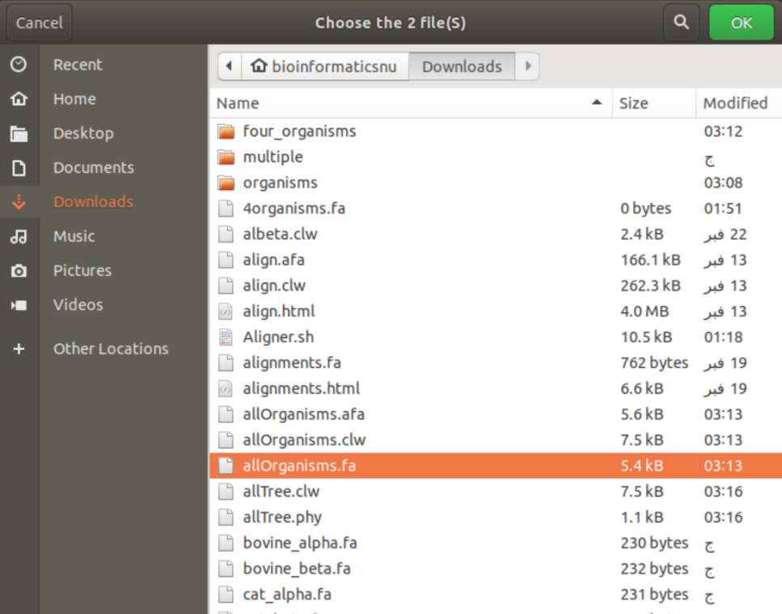

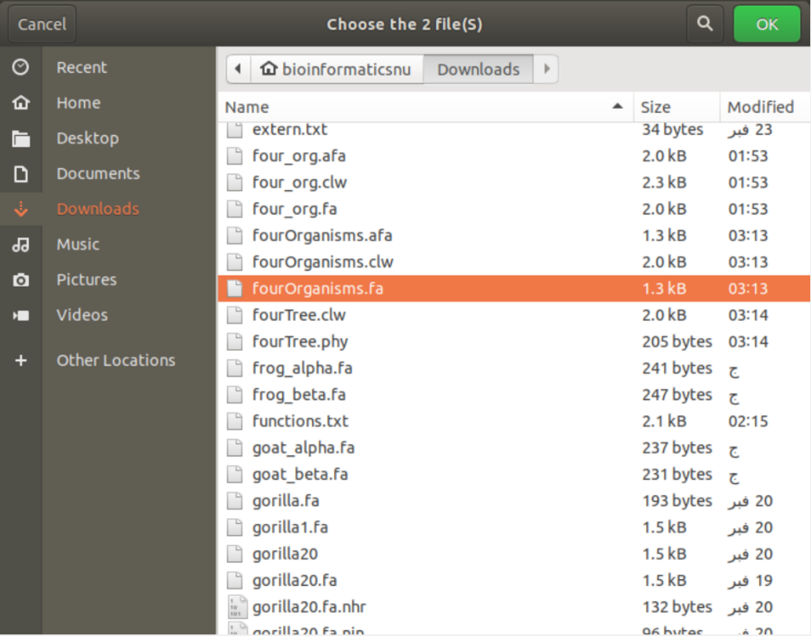

Here the tool takes the counts of the kmers in these files and store it in the graph file as well.

The result of the graph will be generated; this will be shown in the result section. This type of graph used termgraph using this command:

$ termgraph $graph.txt --width 30 --different-scale --title "counts of kmers" --delim space

Moreover, we did the same steps but instead choosing terminal we have chosen barplot graph as shown:

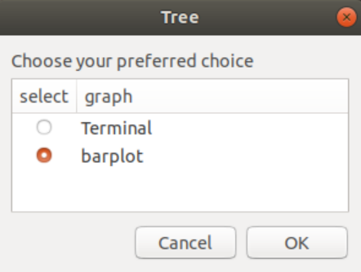

Aligner asks the user for the name of output file as well.

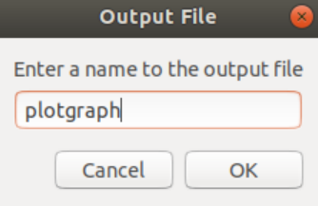

And all the previous steps made in the terminal graph will be made as well. But here, the output file which stores all the counts and data to be visualized will be used in another script responsible for the barplot.

set terminal png

set datafile separator whitespace

set style data histogram

set style histogram clustered gap 6

set style fill solid 1 noborder

set xtics scale 0

set yrange [1:]

plot for [i=2:${#x2[@]}+1] '$graph2.txt' using i:xtic(1) title columnheader

" >> $graph2.plot

then this script will be used by gnuplot to generate the graph using this command:

$ gnuplot $graph2.plot > $graph2.png

the graph then will be shown to the user and stored as a png image in the same directory opened. It will be shown in the result section.

## 2.3 Tool analysis

Our toolbox is now ready for all the 6 functions it performs. As it is said, Aligner is a command-based tool, but we added a GUI for better visualization and better for catching many errors besides showing some notifications to notify the user in some cases. We used zenity and yad libraries for the GUI.

[1] Firstly, Aligner catches any error and exit the program besides exiting it when any cancel button is pressed or the user answers no in any case. For example, in the first menu, if the user enters number 7 which is not in the list, the tool will show a warning that it is invalid choice

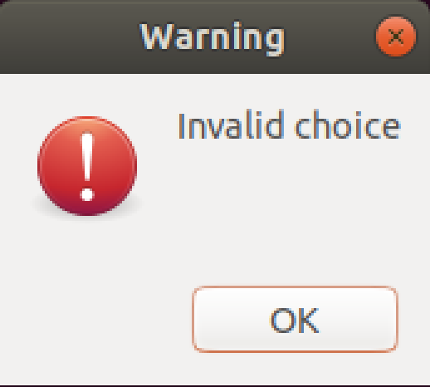

And when cancel or no button is pressed, instead of continuing to the next command, the tool will exit.

[2] besides, inside the bash script all the tools used will be installed before by this command:

$ sudo -A apt-get install $tool

And the -A parameter to take the password of the device without entering it through terminal so the tool can be completely used without opening the terminal itself.

[3] In the file selection in any function, Aligner only shows the file the tool wants. For example, in the pairwise alignment, this function can be done only on fasta files so the tool opens the file selection window with only files with extensions fa or fasta appears and the rest of the files will be disappeared. This can be cleared in the right bottom in the figure.

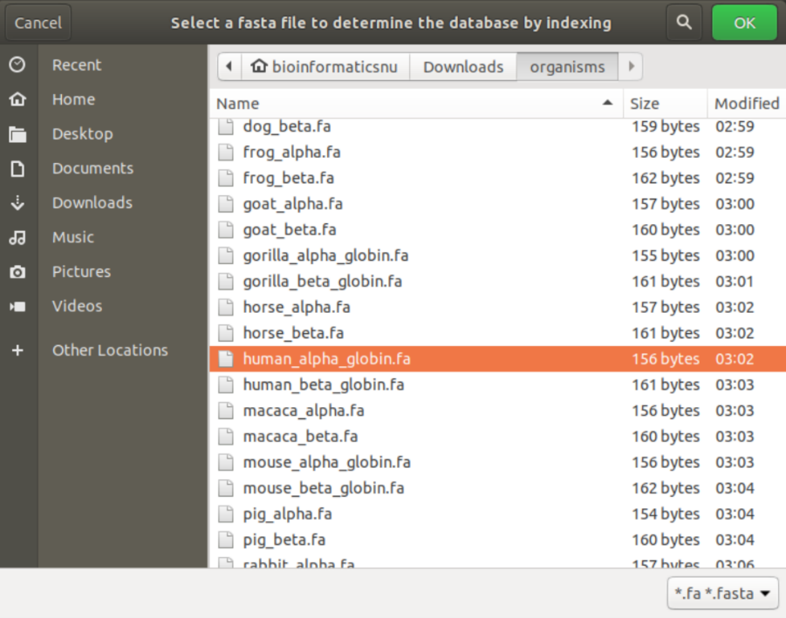

Besides in the multiple sequence alignment, the user can only choose a folder and if he selects a file instead the tool will not accept it.

[4] finally, the notification in zenity helps the tool to notify zenity with any information in any step. By using this command:

$ notify-send "Multiple Sequence Alignment" "$MSA_file is created"

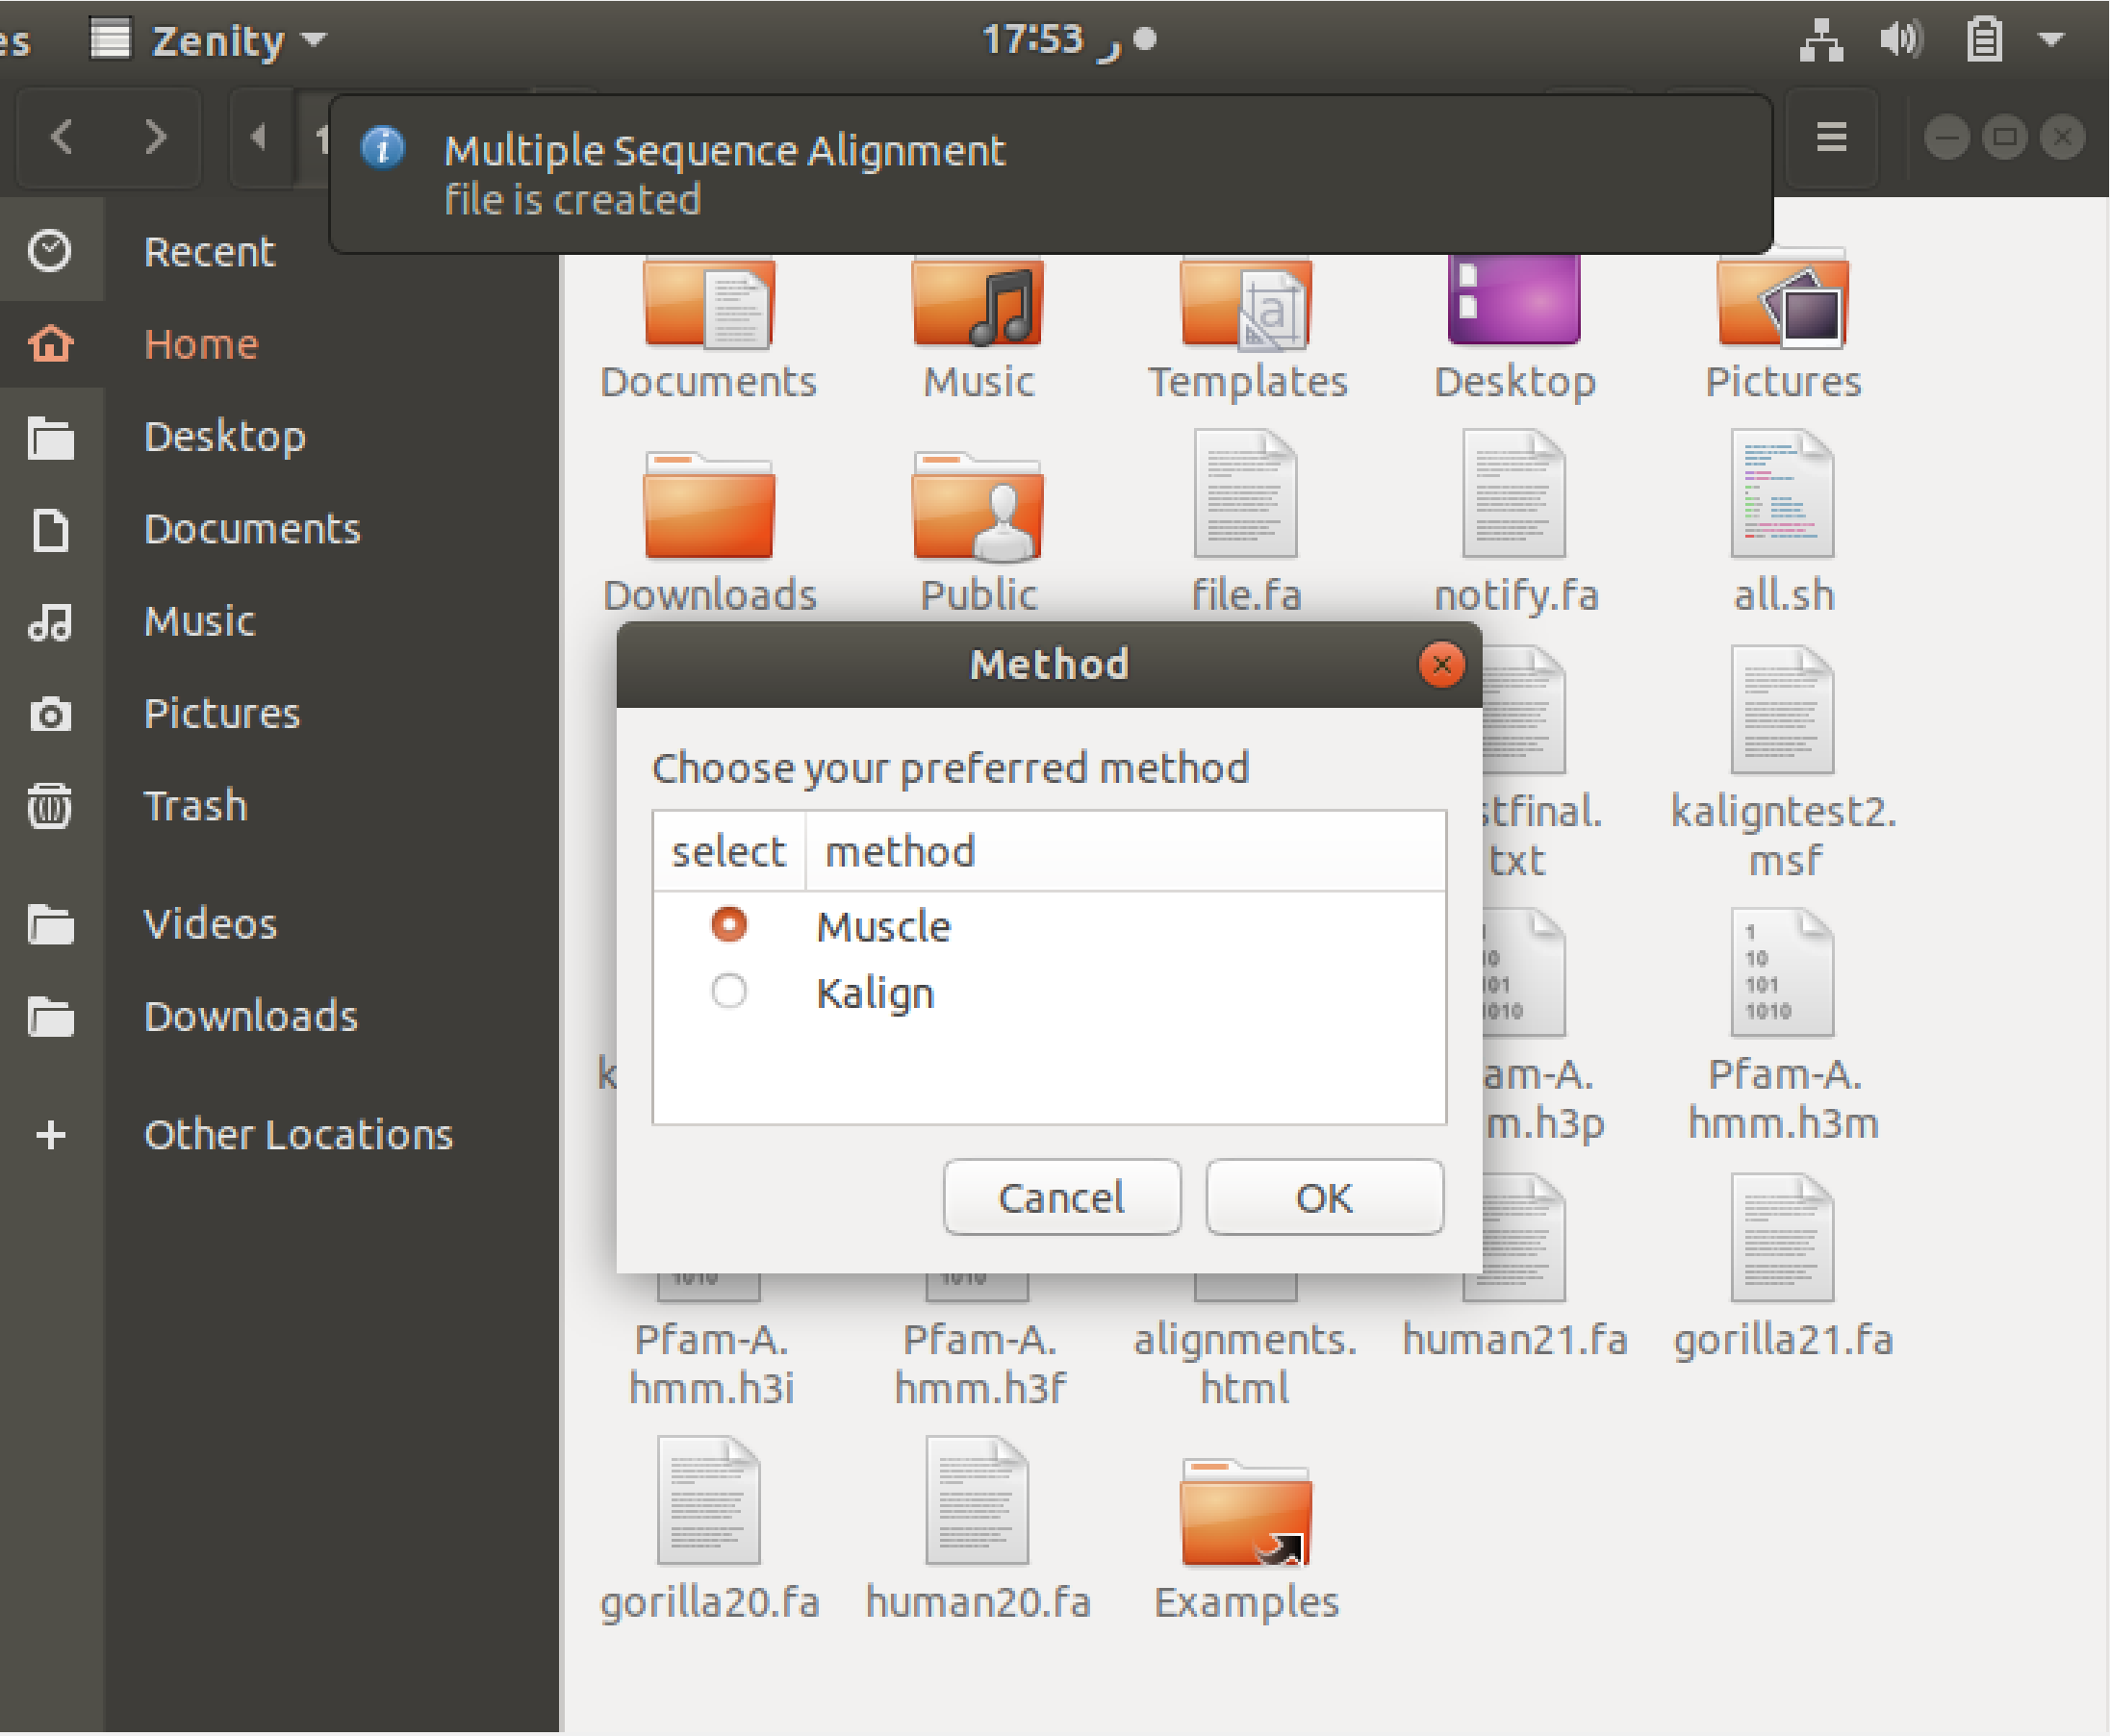

Besides many notifications is set in the tool in each step.

# 3. Results

## 3.1 Pairwise Alignment

Firstly, the result of the makeblastdb command, its output is 3 files of extensions be nhr, nin and nsq as the database type is protein. These files are the indexing files resulted from indexing process as we said before in the methodology section.

By Aligner, we tried the protein sequence files for the pairwise alignment between fasta file of human_alpha_globin.fa and gorilla_alpha_globin.fa. This massage appears when the pairwisel alignment is generated

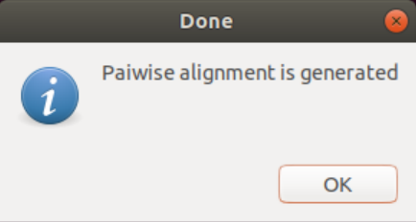

The output file is placed in the same directory the user open. It is shown in the below figures:

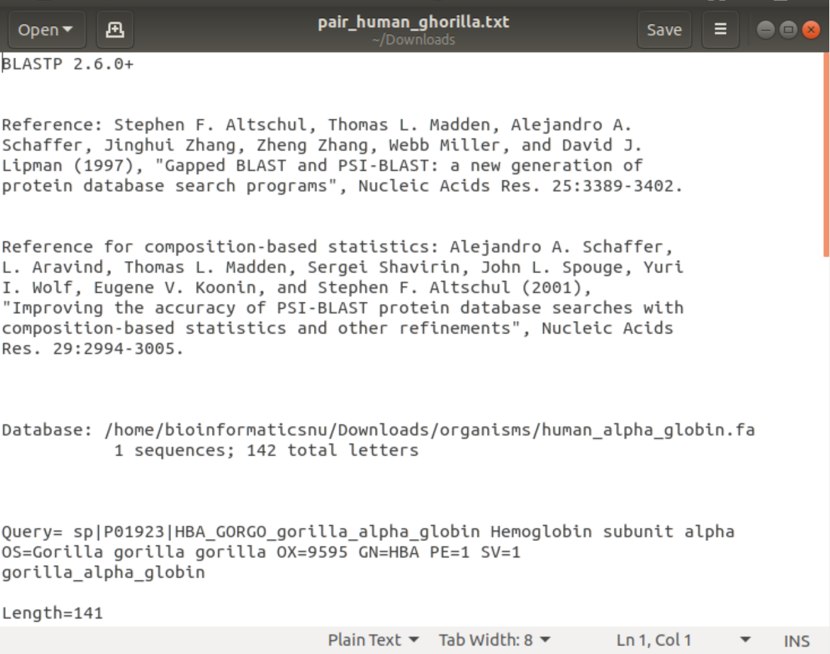

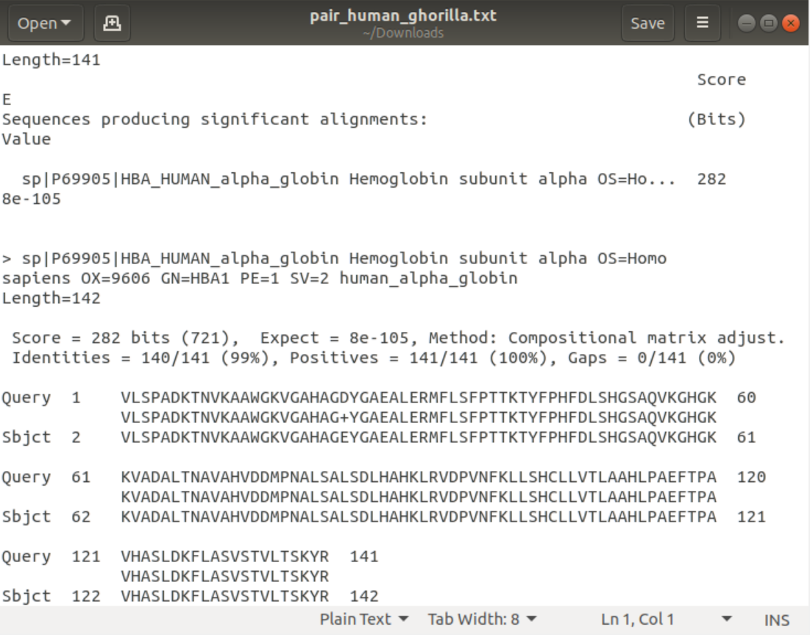

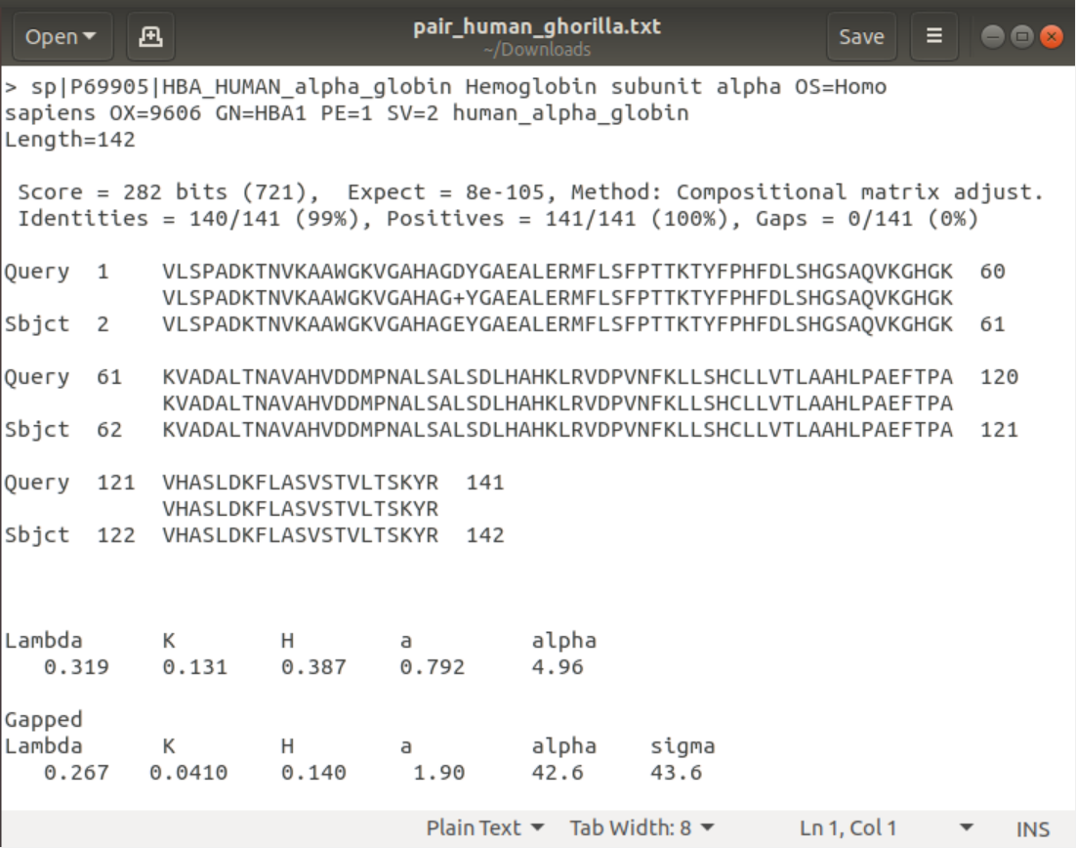

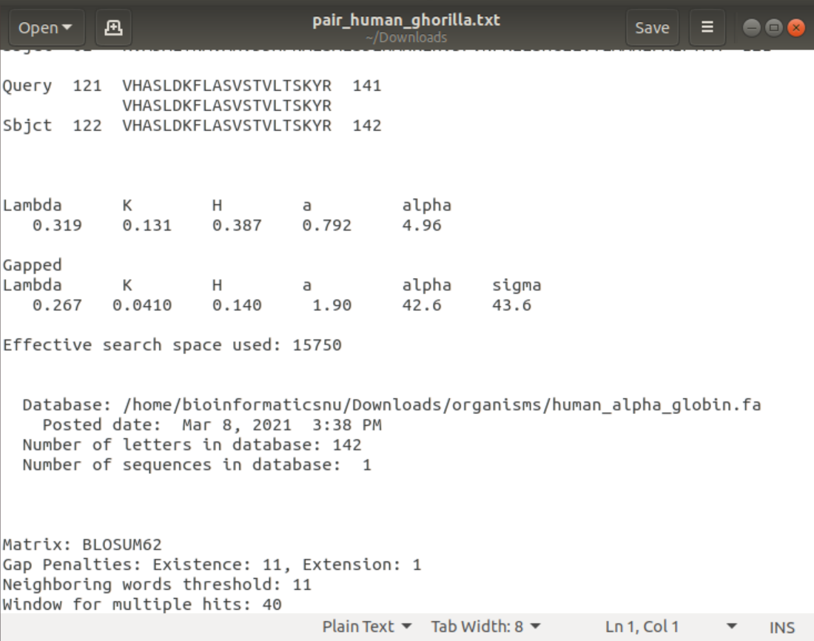

These resulting files have many alignments each has its own identity and score, the score is the total number calculated from the matches and mismatches founded, this value is computed from the scoring matrix and gap penalties. A higher score indicates greater similarity. The raw score is shown without units, and the normalized score is followed by "bits." The scoring system can be as simple as “+1” for a match and “-1” for a mismatch between the pair of sequences at any given site of comparison.

In the context of alignments displayed in BLAST output, positives are those non-identical substitutions that receive a positive score in the underlying scoring matrix, BLOSUM62 by default. Most often, positives indicate a conservative substitution or substitutions that are often observed in related proteins.

Expect is the E- value and it is a parameter that describes the number of hits one can "expect" to see by chance when searching a database of a particular size. It decreases exponentially as the Score (S) of the match increases.

The identity shows how many nucleotides or amino acids in this segment and how many does it match.

While the gaps (which are the missing nucleotides or amino acids between the alignment of the two sequences) shows how many gaps are located from the total number of nucleotides or amino acids.

Besides, if the database type is DNA, the file will contain parameters as plus and minuc. the plus parameter shows what strand this site takes. DNA is a double-stranded molecule, and genes may occur on either strand and when a query sequence is searched against a database, both strands of the query are examined. The plus strand is the sequence in the FASTA file.

The minus strand is the reverse complement of this sequence. So, the strand can be plus/plus, plus/minus, minus/plus, minus/minus.

The query sequence is always listed first which is in our case is the gorilla chromosome. The database sequence is abbreviated as Sbjct (subject) which is the human chromosome.

The number beside the query is the number of the beginning of the sequence in the human file while the number below is the number of the end of the sequence. Same as the sbjct.

The lines between the sequences mean the similarities which is called the conserved regions, domain or motifs that have a specific function in the two organisms. While the empty spaces are the mismatches. Besides, the dashes are the gaps founded between them.

Also, E-value=0.0 indicates that the “match” is more significant in both pairwise alignments. The closer the e-value is to zero, the more significant (and less of a potential false positive) the match is considered to be.

## 3.2 Multiple Sequence Alignment

After all the steps are done, the MSA is generated producing to the user this message

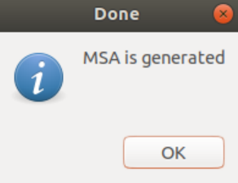

Now the generated files are placed within the same directory the user open.

The firstly generated file was the file which combine all the fasta files which we made the MSA on,

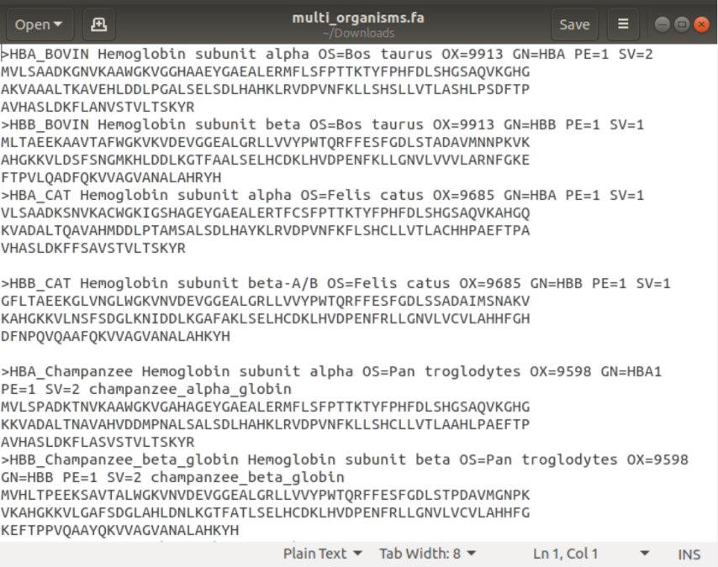

Then, the main output which is the afa file is generated by aligner

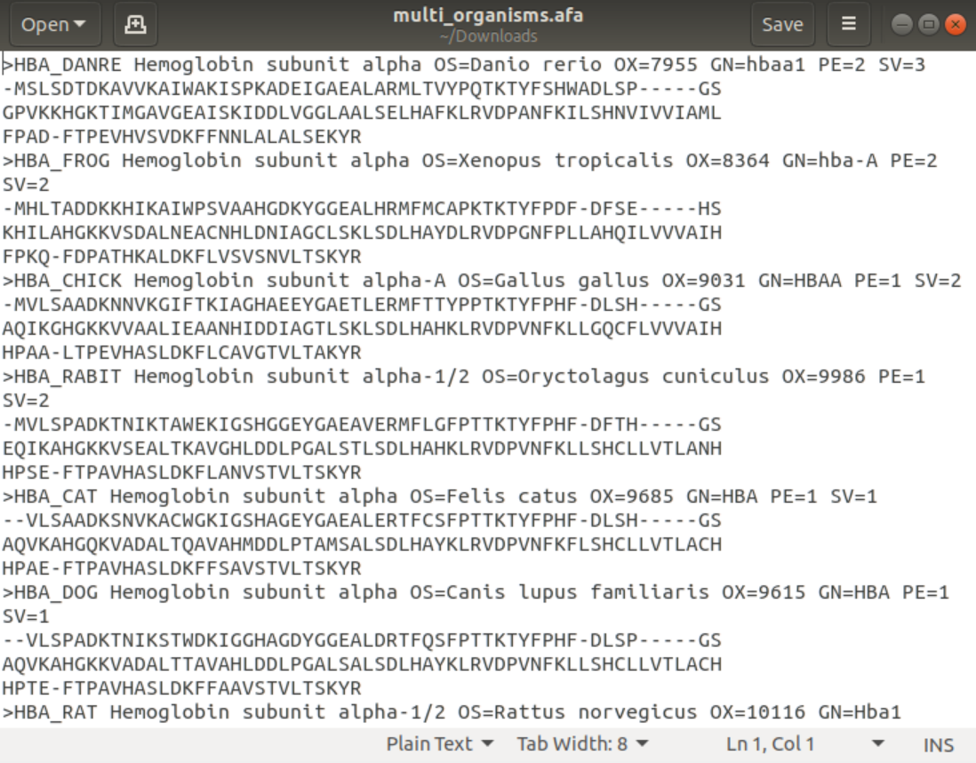

These dashes (-------) indicates the gaps between the sequences. The output of the combined alignment fasta file(.afa) is used to output clustalw and html output formats which helped us to recognize the conserved regions as we said before in the methodology section, It indicates function between the two organisms and also the similarity as the nucleotides are identical in these regions. The difference is that clustalw indicates the conserved regions by stars (*) under these regions. In html web page the conserved regions are signed by a blue color, the semi conserved regions are signed by a grey color and the regions that are not identical are signed by the white color. while the result from protein sequence specialied with (*) identify identical amino acids and with (:) identify amino acids have similar properties and functions and also with (.) identify amino acids that may be probable to have same functions and properties.

Then, the clw file was generated

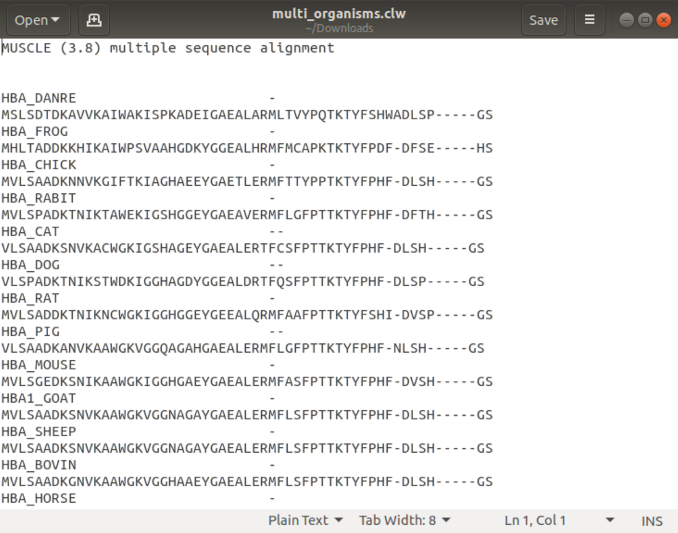

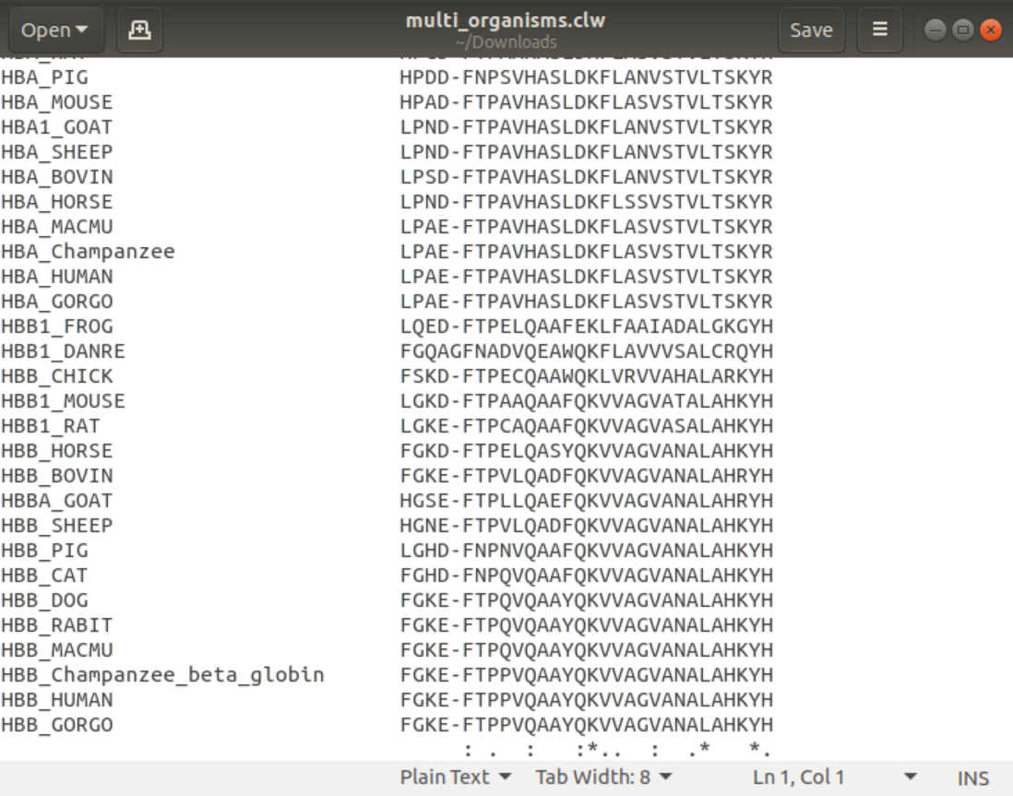

Secondly, the html file was produced when we chose the html format

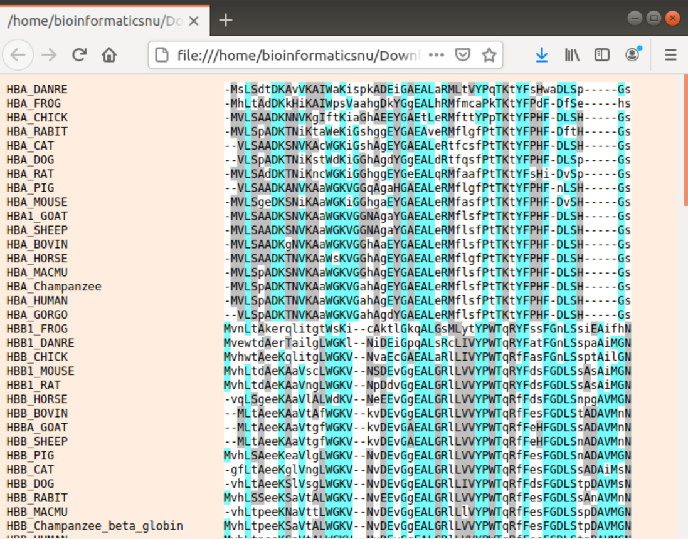

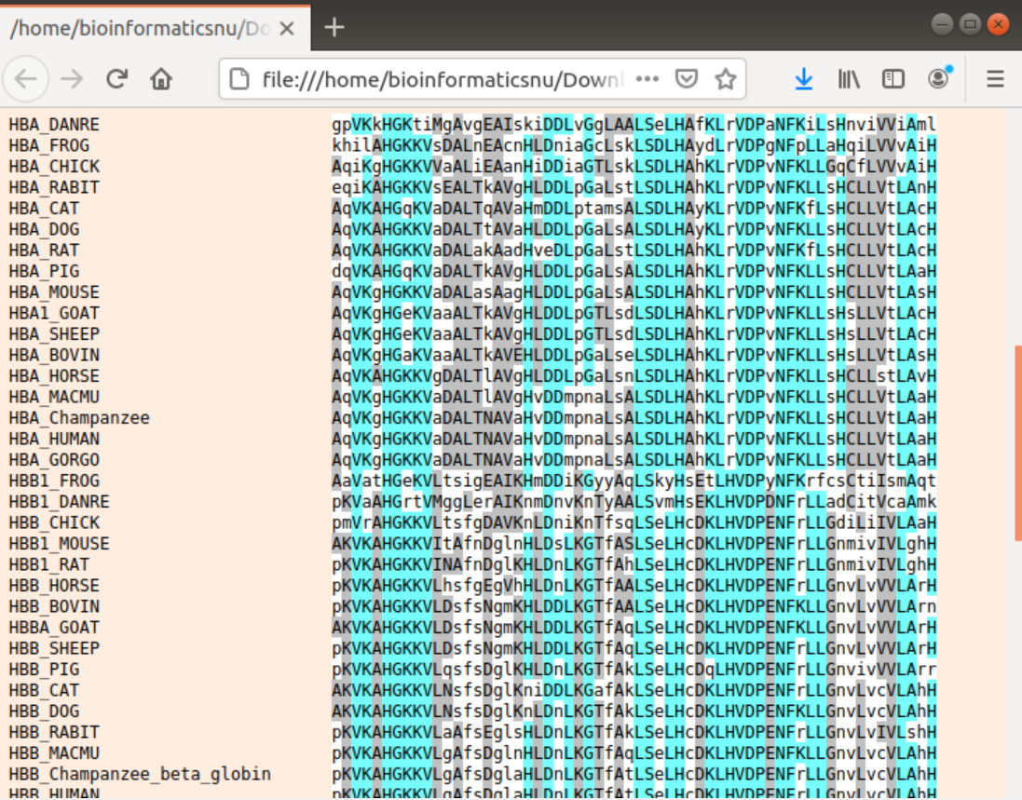

The blue regions indicate the conserved regions that have a function in the organisms. The grey one indicates the semi conserved and the white indicates the not conserved at all.

When we tested kalign, an afa file was generated as well besides the clu and MSF files

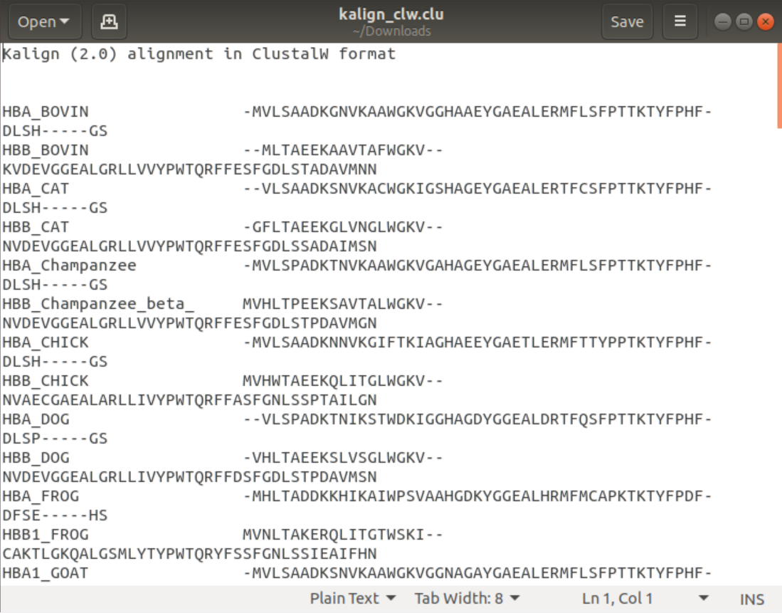

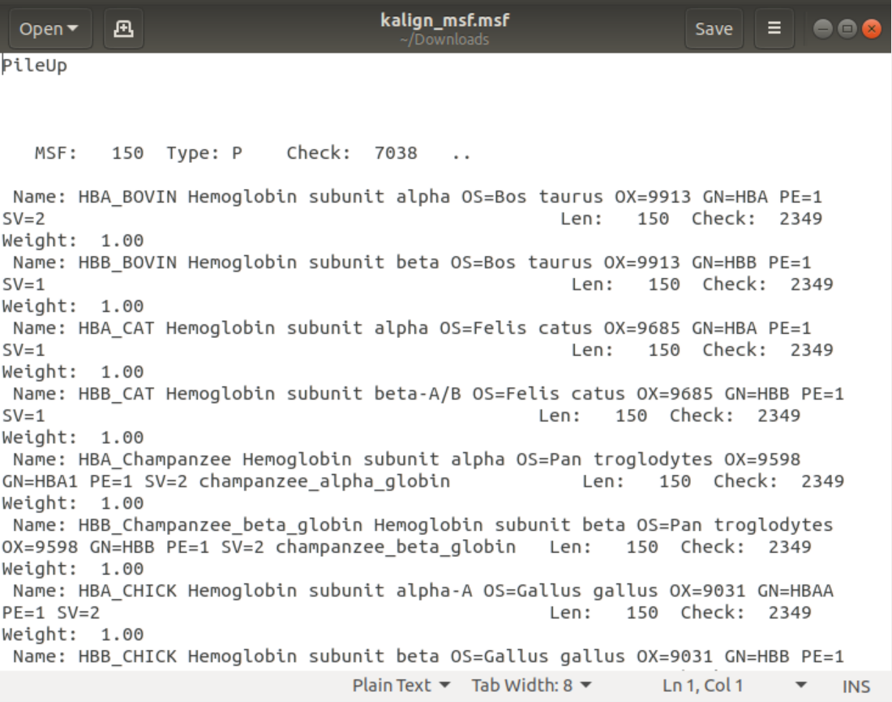

As shown in all figures, the best view of all files was the clastalw file generated by muscle as it is organized and partitioned into regions signed by stars indicates the conserved regions that have a function in all these organisms.

## Conserved Regions

After pressing any type of format, the file is previewed with an information box describing the conserved region in this type of format and each was explained in the MSA section result.

The clw file:



The html file:





In case of the clw and choosing to show the function from pfam. These results were generated:

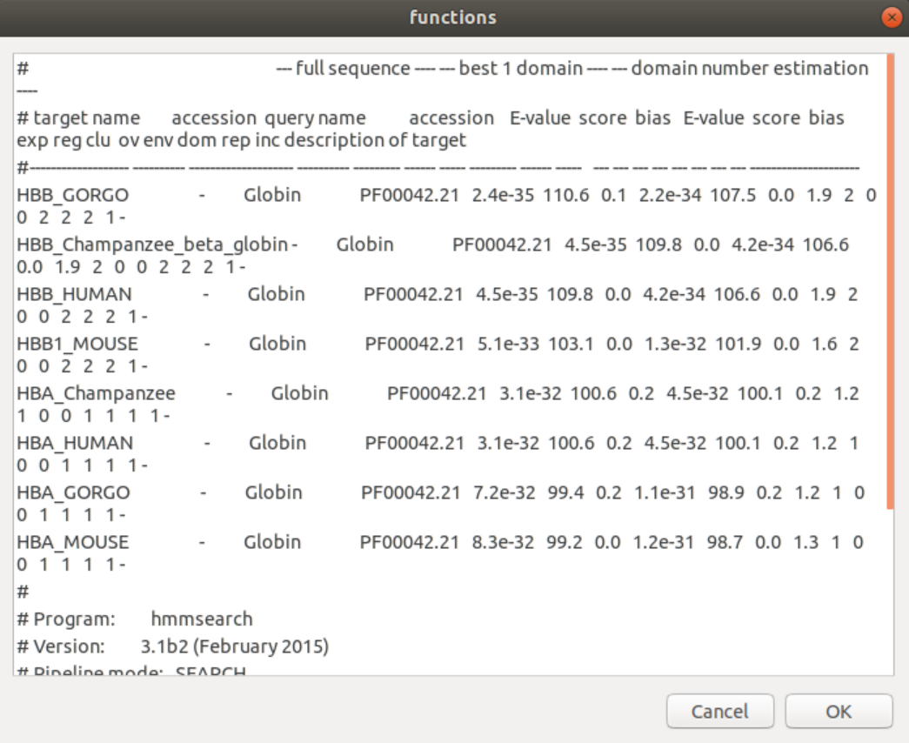

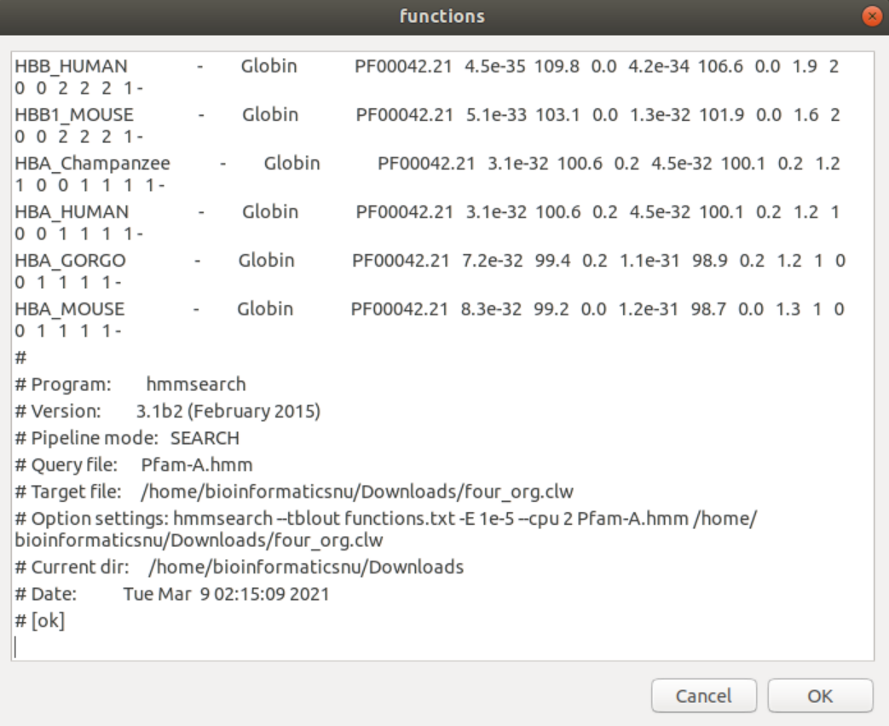

The result of the pfam shows the identity of these organisms to each other. Displaying the e-value, as e value is small that means that there is a higher similarity between organisms. Showing also the bias, accession number of these organisms and the score of similarity. Pfam shows the family of the sequence of protein entered which is Globin family. Globin is a subunit of Hemoglobin gene which transport oxygen via blood in organisms as we said before.

In Aligner tool if user enters another options except clw the tool will display an information message about that option (output file format as clu, MSF, html) but will not open pfam as we mentioned.

## Phylogenetic Tree

Tree file is generated in newick format.

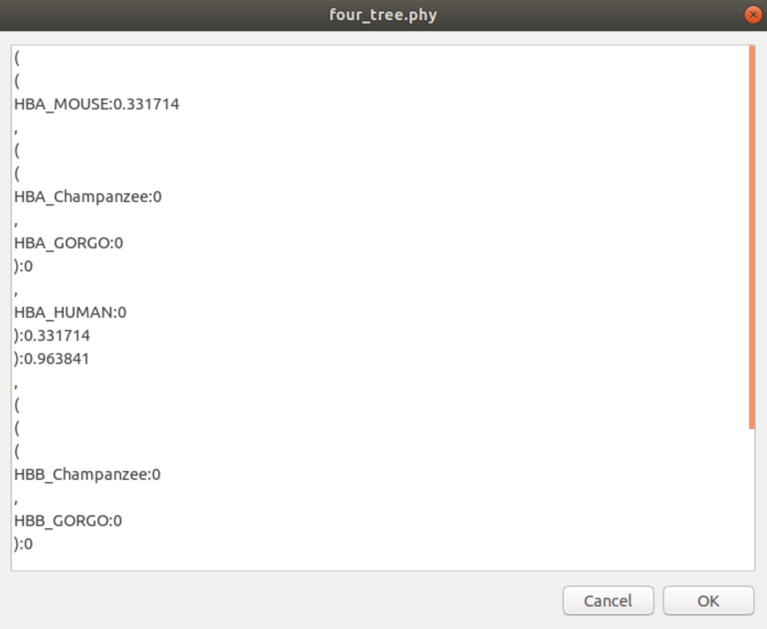

The This tree file indicates This tree graph indicates that human, gorilla and chimpanzee alpha globin genes are more related to each other and they came from the same ancestor. There is a huge similarity between the alpha genes of these organisms as they all are on the same branch of tree. Beside, mouse is less related to these organisms and didn’t came from the same ancestor so the similarity is not large as well. Same in beta globin gene. And the 2 genes are related to each other but not have large similarity. This indicates that human, gorilla and chimpanzee have arisen from the same common ancestor and are more similar and related to each other.

If user select visualize not newick, a tree graph will be represented as shown in the figure:

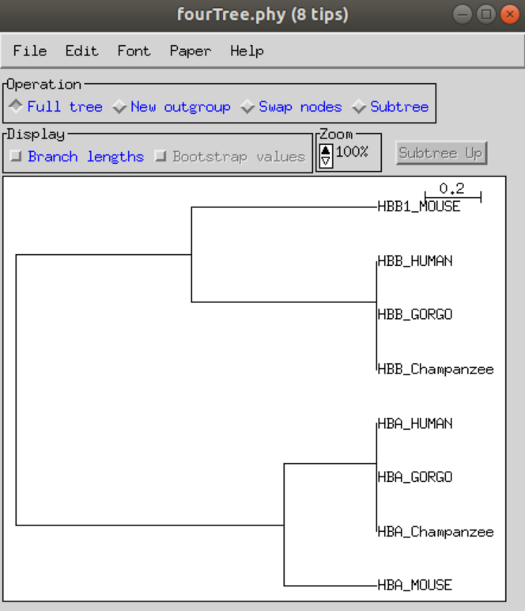

This tree graph indicates that human, gorilla and chimpanzee alpha globin genes are more related to each other and they came from the same ancestor. There is a huge similarity between the alpha genes of these organisms as they all are on the same branch of tree. Beside, mouse is less related to these organisms and didn’t came from the same ancestor so the similarity is not large as well. Same in beta globin gene. And the 2 genes are related to each other but not have large similarity. This indicates that human, gorilla and chimpanzee have arisen from the same common ancestor and are more similar and related to each other.

Besides, the result of the folder that is containing all the organisms, the newick format:

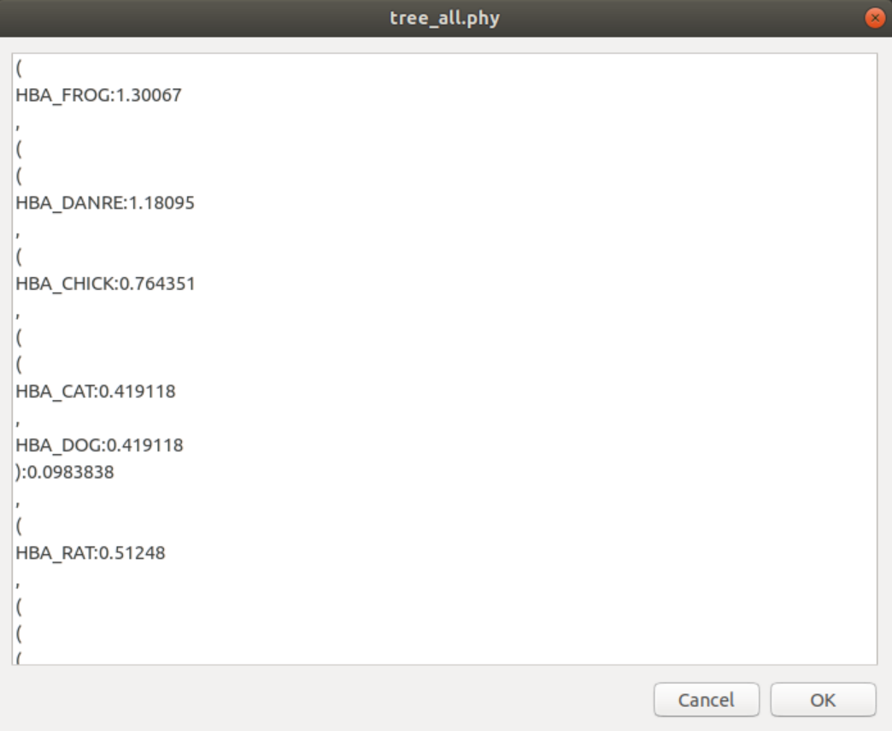

The visualization:

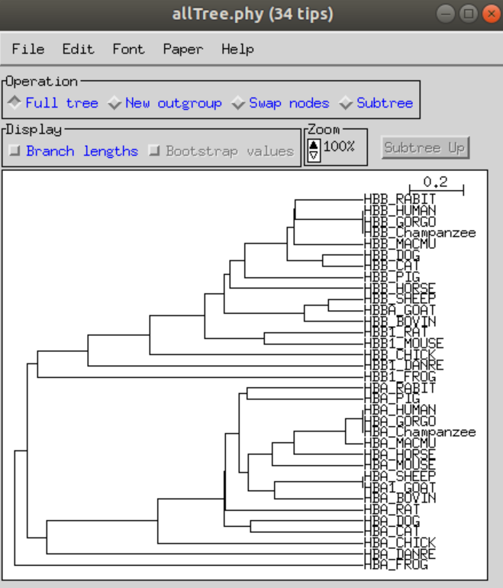

This tree graph indicates that human, gorilla and chimpanzee beta globin genes are more related to each other and have a huge similarity as they are arising from the same branch this means that they have arisen from a common ancestor. Rabbit is more related to these three organisms so it may have a large percentage of similarity. Also macmu is more related to these three organisms. But rabbit and macmu are less related to each other as they came from different branches and don’t arrive from a common ancestor. Cat and dog are more related to each other as they came from the same branch of tree this means that they have arisen from a common ancestor. All the previous organisms are more related to cat and dot as there is a link branch between them so that indicates a similarity between these organisms. Goat and sheep are more related to each other as they came from the same branch of tree this means that they have arisen from a common ancestor. Goat and sheep are more related to bovine as there is a link branch between them. Rat and mouse are more related to each other as they came from the same branch of tree this means that they have arisen from a common ancestor. Chicken is less related to these organisms also frog and horse as well. In respect to alpha globin genes, rabbit and big have a huge similarity and more related to each other. They came from the same branch, so they have arisen from a common ancestor. Human, gorilla and chimpanzee alpha globin genes are more related to each other and have a huge similarity as they are arising from the same branch this means that they have arisen from a common ancestor. Macmu horse and then mouse is more related to these three organisms. Sheep and goat are are more related to each other as they came from the same branch of tree this means that they have arisen from a common ancestor. Goat and sheep are more related to bovine as there is a link branch between them. Cat and dog are more related to each other as they came from the same branch of tree this means that they have arisen from a common ancestor. Chicken is more related to dog then frog is related also but less related. The 2 genes of alpha and beta of all these organisms are related to each other as there is a link branch of tree between them but not have large similarity.

## 3.5 Counting kmers

If user enter a kmer KA as shown in the methodology section, the result will be as shown:

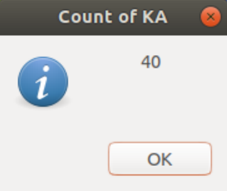

Here, Aligner generates the count successfully.

## 3.6 Graph

For the first option which is the terminal graph, the graph was printed on an information box as shown with all the counts of M, L, R in the two files but as we see the graph is not colored and not stored on the computer itself so the barplot graph is a better option.

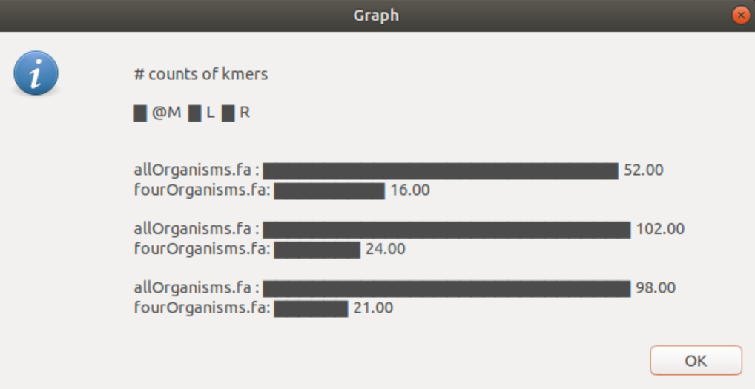

Barplot option was better as shown in the next figure:

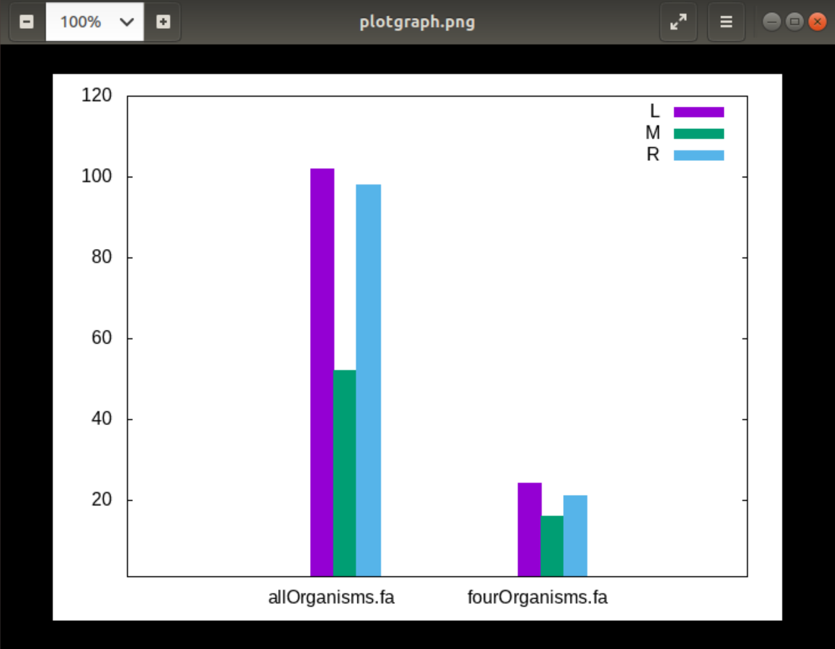

It is colored, well labeled and shows the difference of the counts between the 2 files. As we mentioned the file was also stored in the same directory as a png photo.

# 4. References

1. [https://www.ensembl.org/index.html#:~:text=Ensembl%20is%20a%20genome%20browser,seq uence%20variation%20and%20transcriptional%20regulation.&text=Ensembl%20tools%20includ e%20BLAST%2C%20BLAT,VEP)%20for%20all%20supported%20species.](https://www.ensembl.org/index.html#:~:text=Ensembl%20is%20a%20genome%20browser,sequence%20variation%20and%20transcriptional%20regulation.&text=Ensembl%20tools%20include%20BLAST%2C%20BLAT,VEP)%20for%20all%20supported%20species)
2. [https://www.khanacademy.org/science/high-school-biology/hs-evolution/hsphylogeny/a/phylogenetic-trees](https://www.khanacademy.org/science/high-school-biology/hs-evolution/hs-phylogeny/a/phylogenetic-trees)
3. [https://www.nature.com/scitable/topicpage/reading-a-phylogenetic-tree-the-meaning-of-](https://www.nature.com/scitable/topicpage/reading-a-phylogenetic-tree-the-meaning-of-41956/)

[41956/](https://www.nature.com/scitable/topicpage/reading-a-phylogenetic-tree-the-meaning-of-41956/)

1. <https://www.britannica.com/science/phylogenetic-tree>
2. [https://microbenotes.com/how-to-construct-a-phylogenetictree/#:~:text=A%20phylogenetic%20tree%20is%20a,common%20ancestor%20to%20different% 20descendants.&text=Thus%2C%20molecular%20phylogenetics%20is%20a%20fundamental%20 aspect%20of%20bioinformatics.](https://microbenotes.com/how-to-construct-a-phylogenetic-tree/#:~:text=A%20phylogenetic%20tree%20is%20a,common%20ancestor%20to%20different%20descendants.&text=Thus%2C%20molecular%20phylogenetics%20is%20a%20fundamental%20aspect%20of%20bioinformatics)
3. <https://www.ebi.ac.uk/Tools/psa/>
4. <https://www.biostars.org/p/212594/>
5. <https://www.uniprot.org/>

# 5. Contributions

Moaz Rizkallah:

1. Pairwise alignment using blast between each pair of chromosomes in each two organisms

Menna Abdelsattar:

1. Multiple sequence alignment
2. Conserved regions
3. phylogenetic tree

Mennatullah Mahmoud:

1. Counting kmers
2. Graph
3. Pfam in the tool
4. GUI
5. Tool analysis section